Bushfire hazard overlay code

Application
This code applies to assessing material change of use, reconfiguring a lot or operational works within the Potential impact buffer or Medium, High or Very high potential bushfire intensity area identified on the Bushfire hazard overlay maps contained in Schedule 2.

When using this code, reference should be made to Part 5.

Note – The Bushfire hazard overlay code does not apply to Building Works applications. Building works are assessable under the relevant Building Assessment Provisions and not this planning scheme. Refer also to section 1.6 of this planning scheme.

Editor’s Note – For the purposes of the Building Code of Australia and AS3959 Construction of Buildings in Bushfire-Prone Areas the land identified within the Bushfire overlay is designated as a bushfire prone area.

Purpose
- The purpose of the Bushfire hazard overlay code is to ensure that development minimises the potential adverse impacts of bushfire on people, property and the environment.
- The purpose of the code will be achieved through the following overall outcomes:
  - development is protected from bushfire hazards and maintains the safety of people and property;
  - development avoids the Potential impact buffer and the medium, high and very high potential bushfire intensity areas;
  - development has suitable access to water for fire fighting purposes;
  - development does not increase the risk of fire hazards;
  - community infrastructure is able to function effectively during and immediately after bushfire events.

Assessment benchmarks and requirements
Table 8.2.4.3.a – Bushfire hazard overlay code – assessment benchmarks for assessable development and requirements for accepted development
Performance outcomes | Acceptable outcomes | Applicant response
For accepted development subject to requirements and assessable development
Safety of people, property and the environment
PO1  Development maintains the safety of people and property by:  - avoiding areas of Potential impact buffer or Medium, High or Very high potential bushfire intensity or  - mitigating the risk through:  - the siting of development;  - including firebreaks that provide adequate:  - setbacks between lots/buildings/structures and hazardous vegetation;  - access for firefighting/other emergency vehicles.  - adequate road access for firefighting/other emergency vehicles and safe evacuation;  - adequate and accessible water supply for firefighting purposes.  Note – The preparation of a Bushfire Management Plan may be required to demonstrate achievement of the Outcome. Planning scheme policy - Natural hazards, provides a guide to the preparation of a Bushfire Management Plan. | AO1.1  Development is not located in an area of Potential impact buffer or Medium, High or Very high potential bushfire intensity area.
For assessable development

Performance outcomes | Acceptable outcomes | Applicant response
Safety of people, property and the environment
PO2  Development maintains the safety of people and property by:  - avoiding areas of Potential impact buffer or Medium, High or Very high potential bushfire intensity; or  - mitigating the risk through:  - lot design and the siting of development;  - including firebreaks that provide adequate:  - setbacks between buildings/structures and hazardous vegetation;  - Access for firefighting/other emergency vehicles.  - provide adequate road access for firefighting/other emergency vehicles and safe evacuation;  - providing adequate and accessible water supply for firefighting purposes.  Note – The preparation of a Bushfire Management Plan may be required to demonstrate achievement of the Outcome. Planning scheme policy - Natural hazards, provides a guide to the preparation of a Bushfire Management Plan. | AO2.1  Lots are designed so that their size and shape allow for efficient emergency access to buildings for fire-fighting appliances (e.g. by avoiding long narrow lots with long access driveways to buildings).
AO2.2
Development (including the potential for future buildings or structures) on lots:
- are sited in locations of lowest hazard within the lot;
- provide a minimum building setback from hazardous vegetation of 20 metres or the distance required to achieve a Bushfire Attack Level BAL-29 (as identified in AS3959), whichever is the greater.

Performance outcomes | Acceptable outcomes | Applicant response
AO2.3
Firebreaks are provided by:
- a perimeter road that separates lots from areas of bushfire hazard and that road has :
  - a minimum cleared width of 20 metres;
  - a constructed road width and weather standard complying with Planning scheme policy – FNQROC Regional Development Manual;
or

- a fire maintenance trail/s located as close as possible to the boundaries of the lots and the adjoining bushfire hazard, and:
  - have a minimum cleared width of 6 metres;
  - have a minimum formed width of 4 metres;
  - have a gradient that does not exceed 25%;
  - have a cross slope that does not exceed 5%;
  - connect to roadways at each end and have passing bays at least every 200m, with access points at least every 400m - where possible.

or
 | (c) sufficient cleared breaks of 6 metres minimum width in retained bushland within the development (e.g. creek corridors and other retained vegetation) to allow burning of sections and access for bushfire response.

Performance outcomes | Acceptable outcomes | Applicant response
AO2.4
Roads are designed and constructed in accordance with Planning scheme policy – FNQROC Regional Development Manual;
- have a maximum gradient of 12.5%;
- exclude cul-de-sacs, except where a perimeter road isolates the development from hazardous vegetation or the cul-de-sac are provided with an alternative access linking the cul-de-sac to other through roads.

Note – Figure 8.2.4.3.a provides guidance on meeting the outcomes.
AO2.5
For uses involving new or existing buildings with a gross floor area greater than 50m², each lot has a reliable reticulated water supply that has sufficient flow and pressure characteristics for firefighting purposes at all times being a minimum pressure and flow is 10 litres a second at 200 kPa.
PO3  Development does not materially intensify the use of bushfire prone areas. | AO3.1  Development does not result in a high concentration of people living or working in an area at risk from bushfire (e.g. accommodation activities, business activities, centre activities, community activities, entertainment activities, industry activities or involve institutional uses where evacuating people may be particularly difficult (e.g. Child care centre, Residential care facility and Detention facility).
AO3.2
Development within High or Very high potential bushfire intensity areas complies with a Bushfire Management Plan for the premises.
AO3.3
Bushfire hazard is minimised with planting of

Performance outcomes | Acceptable outcomes | Applicant response
bushfire resistant species near areas of Potential impact buffer or Medium, High and Very high potential bushfire intensity identified on the Bushfire hazard overlay maps contained in Schedule 2.

Note – Planning scheme policy – Natural hazards, provides a guide to the preparation of a Bushfire Management Plan.
PO4  Community infrastructure is able to function effectively during and immediately after bushfire events. | AO4.1  Development complies with a Bushfire Management Plan for the premises.  Note – Planning scheme policy – Natural hazards, provides a guide to the preparation of a Bushfire Management Plan.
PO5  Public safety and the environment are not adversely affected by the detrimental impacts of bushfire on hazardous materials manufactured or stored in bulk. | AO5.1  Uses that include manufacturing or storage of hazardous materials do not occur or are adequately separated from the hazard area and the development complies with a Bushfire Management Plan for the premises.  Note – Planning scheme policy – Natural hazards, provides a guide to the preparation of a Bushfire Management Plan.
Scenic amenity
PO6  Bushfire management measures do not have a detrimental impact on scenic amenity values. | AO6.1  No acceptable outcomes are provided.
Natural areas
PO7  Bushfire management measures are designed, located and managed to minimise impacts on natural areas. | AO7.1  No acceptable outcomes are provided.

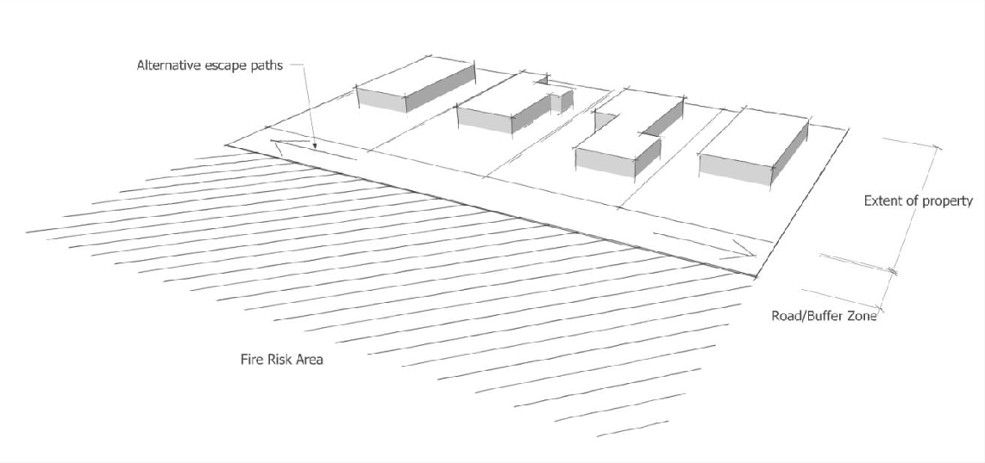
Figure 8.2.4.3.a – Buffer zones for bushfire risk areas

