Earlville local plan code

Application
This code applies to development within the Earlville local plan area as shown on the Earlville local plan maps contained in Schedule 2.

When using this code, reference should be made to Part 5.

Context and setting
This section is extrinsic material under section 15 of the Statutory Instruments Act 1992 and is intended to assist in the interpretation of the Earlville local plan code.

The Earlville local plan area is the focus of retail and business activity for the inner suburbs of Cairns City. It is located approximately 4.5 kilometres west of
the Cairns city centre at the northern end of the Bruce Highway, where it transitions into Mulgrave Road.
Mulgrave Road was originally known as Hop Wah Road as it led to the Hop Wah Plantation where the first sugar mill in the district was built in 1880. The site of the mill was on Clarkes Creek next to the present location of Stockland Shopping Centre. The old name lost its significance after the plantation closed down and the road was renamed Mulgrave Road in 1911.
Originally established in 1980, at the then western periphery of Cairns City Council, the Earlville Shoppingtown (now known as Earlville Shopping Centre) is the dominant built development in the local plan area. However it is complemented by a range of retail and business services predominately focussing on Mulgrave Road and some light industries in areas adjacent to Ishmael Road. The Earlville Major centre offers a high level of retail activity, some community uses and employment in the surrounding area. However the diversity of uses should be increased and the level of amenity and access, particularly pedestrian and public transport are to be improved.
Earlville is considered to be one of the best opportunities for the development of a transit orientated community given the size of the centre, existing mix of uses, nearby higher density residential areas and a range of services. An emphasis will be placed on the renewal of the older housing stock into higher density housing that will support the transit orientated initiatives proposed for Earlville. Development opportunities for higher residential densities exists within the Earlville Local Plan area to protect the lower, established lower density residential neighbourhoods in the surrounding communities.

Two main precincts will be established in the Earlville Major centre over time providing for a high intensity residential and mixed use core and a supporting mixed use commercial frame where activity is consolidated and supported by higher residential densities. Buildings in these precincts are higher than surrounding communities but also have high quality streetscapes, pedestrian environments and incorporate high quality urban design outcomes.
The focus of the transit network in Earlville will be on the Mulgrave Road frontage of the Earlville Core precinct, However in the longer term, public transport will service Ishmael Road as development increases the pedestrian and mixed-use appeal of the secondary road. The increased presence of public transport options in Earlville will make access easier for local residents and patrons coming from outside areas over time.
The effective walkable catchment in Earlville is complicated by a number of barriers including limited crossing opportunities along Mulgrave Road, creek and drainage corridor crossing restrictions and level changes between precincts. The significant planning challenge for Earlville is to establish more convenient and comfortable pedestrian and cycling connections that overcome the difficulties presented by current physical restrictions.

Purpose
- The purpose of the Earlville local plan code is to establish the Earlville local plan area as a:
  - Major centre within the Cairns region;
  - transit-orientated, mixed-use community with supporting areas of higher residential densities;
  - highly connected and self-contained community.

- The purpose of the code will be achieved through the following overall outcomes:
  - the Earlville Shopping Centre site is consolidated as the core of retail activity within the Earlville local plan area;
  - a frame of mixed-use, commercial and retail uses increase employment opportunities and support the core with a range of higher residential densities;
  - development that promotes mixed-use, transit orientated development is established in key locations;
  - industrial buildings to the east of Ishmael Road continue to be used for light and service industries and transition through new development to mixed- use commercial and residential activities that activate Ishmael Road and create a transport supportive environment;
  - the presence of pedestrian friendly spaces and active frontages on major vehicle, public transport and pedestrian thoroughfares is increased;
  - vehicle parking areas are integrated with or behind buildings to ensure they are not dominant visual features of the local plan area;
  - infrastructure, services and activities that support the needs of workers and local residents and recreational facilities are facilitated;
  - appropriately scaled public art and cultural infrastructure is provided;
  - pedestrian and cycle links throughout the local plan area are improved;
  - the provision of a well-planned and high quality public transport station;
  - existing parkland areas as focal points within the urban fabric of the local plan area are retained and reinforced;
  - future development on and around Cannon Park establishes appropriately located road connections to the east and west and connects to the existing and future surrounding road network;
  - the height of buildings and structures is greatest in the Earlville Major centre core and transitions outwards to the frame precinct and surrounding residential areas to ensure:
    - the image and structure of the Major centre emphasises and reinforces its role and function within the hierarchy of centres;
    - lower density residential neighbourhoods beyond the local plan boundaries are not adversely impacted upon;
  - the design of buildings supports the structure of the Earlville Major centre through:
    - a connected and active frontage along Mulgrave Road and Ishmael Road;
    - consolidation of land for more intense development outcomes and higher structures contributing to a compact centre with improved pedestrian environments around buildings;
    - contribute to a positive identity for the Major centre;
  - gateway sites are given significance through their use and built form in:
    - the way they address road, pedestrian, transport connections and public spaces;
    - their architectural design.

Precinct 1 – Earlville core
- In addition to 7.2.3.3(2), the overall outcomes sought for the precinct are:
  - the precinct is the highest order precinct within the centre;
  - the highest order and greatest range of retail and entertainment activities are concentrated within the precinct;
  - buildings and structures within the precinct emphasise the intensity, scale and increased activity within the core through elevated height and separation between buildings with high quality landscaped, pedestrian-focussed environments;
  - the pedestrian appeal of areas at ground level is emphasised through active frontages and comfortable pedestrian spaces and cyclist facilities;
  - connections for pedestrians and cyclists between the precinct and Precinct 2 – Earlville frame are improved.

Precinct 2 – Earlville frame
- In addition to 7.2.3.3(2), the overall outcomes sought for the precinct are:
  - land uses within the precinct are of a scale and intensity complementary to the intensity and scale of those within Precinct 1 – Earlville core;
  - buildings and structures within the precinct emphasise the commercial and mixed-use activity through medium-rise buildings and active frontages;
  - higher residential densities within the precinct are encouraged through consolidation of lots with increased heights and separation from lower density
residential activities;
  - gateways and large allotments in the precinct are used effectively for:
    - commercial activities that require larger floor areas; or
    - mixed-used development which integrate uses vertically rather than across a site.

Precinct 3 – Cannon park
- In addition to 7.2.3.3(2), the overall outcomes sought for the precinct are:
  - uses that transition away from the existing race course occur only at such time as adequate road connections can be delivered to Ishmael Road,
Mulgrave Road and a future by-pass of Earlville to the east;
  - any redevelopment of the precinct is supported by:
    - a detailed structure plan prepared demonstrating how the site may be developed over time;
    - demonstration that the proposed development supports the role of Earlville as a transit oriented community;
    - design, layout or buildings that reflect the significance of the race course to the local history of Cairns;
    - connection to surrounding infrastructure networks.

Note – For code assessable development, the role and function of centres within the hierarchy of centres is outlined in Schedule 6.

Note – For Impact assessable development, the role and function of the hierarchy of centres is described 3.3.2 Element – Centres and centre activities within Part 3 Strategic framework in addition to Schedule 6.

Assessment benchmarks and requirements
Table 7.2.3.4.a – Earlville local plan code – assessment benchmarks for assessable development
Performance outcomes | Acceptable outcomes | Applicant response
For assessable development
Design
PO1  The height of buildings and structures ensures:  - taller buildings on appropriately sized land are constructed to prevent horizontal sprawl, maximising opportunities for public space;  - that there is a transition of building heights from the Earlville core precinct to the surrounding residential neighbourhoods;  - activation through high quality public and semi- public spaces at ground level.  Note – A visual impact assessment may be required where a proposed development exceeds the height stated in AO1.1. Planning scheme policy – Landscape values provides guidance on undertaking a visual impact assessment.  Note – Where a proposed development exceeds the height stated in AO1.1, the proposed setbacks and site coverage will be assessed in relation to the proposed height. | AO1.1  The height and scale of development is consistent with the outcomes specified within Table 7.2.3.4.b.  Note – Height is inclusive of the roof height.
AO1.2
Buildings greater than 4 storeys are set back from property boundaries:
- ½ the height of the building or structure where adjacent to a Residential zone or existing residential development; or
- ¼ the height of the building or structure where adjacent any other zone.

Note – Figures 7.2.3.4.a and 7.2.3.4.b provides visual guidance to the setback provisions for buildings greater than four storeys.

Note – Refer to the definition of Residential zones contained in
Schedule 1.2.
AO1.3
Areas around the building at the ground level are activated through:
- high quality landscaping affording pedestrian comfort and meeting or recreating spaces;
- land uses such as offices, shops or food and drink outlets;
- high quality urban design;
- a positive local character and identity.

Performance outcomes | Acceptable outcomes | Applicant response
Note – AO1.3 will be applied to residential development only where it:
- is within a mixed-use building; or
- has frontage to Ishmael Road or Mulgrave Road (except AO1.3(b)); or
- provides for pedestrian or cycle ways (except AO1.3(b)).
PO2  Development of gateway sites shown on the Earlville local plan maps contained in Schedule 2 results in memorable architecture and distinctive developments in the local area through:  - land uses that contribute to the creation of the  place;  - active frontages to streets, pedestrian and cycle connections, public transport and other public spaces;  - architectural features that create a distinct or  varied built form from buildings around it. | AO2.1  Development on gateway sites:  - contain land uses that contribute to the  precinct intent and outcomes;  - contain active frontages and facades to public spaces and public transport facilities;  - are finished with architectural features such as articulated roof profiles, parapets, awnings and balconies, tropical landscaping, and a range of building materials.  Note – Refer to the definition of Gateway site contained in  Schedule 1.2.
PO3  Development on Ishmael Road and Mulgrave Road provides active frontages and connectivity of streetscape, pedestrian paths and street front spaces promoting integration with surrounding areas. | AO3.1  Development is built to the street front boundary along Mulgrave Road and Ishmael Road.
AO3.2
A cantilevered awning is provided over the footpath, to the full frontage of the site, with a setback of 1 metre from the face of the kerb, and with:
- a maximum height of 3 metres from the footpath level to the underside of the awning; or
- at a height consistent with or stepping up/down to, the awning structures on buildings on adjacent sites.

Performance outcomes | Acceptable outcomes | Applicant response
AO3.3
The street frontage is predominantly populated with land uses such as offices, shops or food and drink outlets.
PO4  Buildings establish a positive urban form and identity for the Earlville Major centre when viewed from public places. | AO4.1  Buildings incorporate a range of materials and finishes, roofscapes, fenestration and shading devices, and architectural features that contribute to an emerging identity for the Earlville Major centre.
Open space, pedestrian and cycle networks
PO5  Development delivers pedestrian, cycling and road connections in locations shown on the Earlville local plan maps contained in Schedule 2 to improve the connectivity within the local plan area and provide public transport supportive neighbourhoods and environments. | AO5.1  No acceptable outcomes are provided.
Car parking area
PO6  Development ensures that off-street parking is not a dominant visual feature of development. | AO6.1  Development ensures car parking areas are not dominant visual features through incorporating:  - articulated and enclosed car parking facilities;  or  - car parking areas that are sleeved behind buildings encompassing land uses; or  - car parking areas that are provided in a number of smaller parts over a large site; or  - car parking areas that are screened through dense landscaping.  Note – Planning scheme policy – Crime prevention through environmental design (CPTED) provides guidance on the incorporation of safe design principles.

Performance outcomes | Acceptable outcomes | Applicant response
Additional requirements for Precinct 1 – Earlville core
PO7  Development in the Precinct 1 - Earlville core represents the highest intensity of retail and commercial land use and building design within the Earlville local plan area. | AO7.1  No acceptable outcomes are provided.
Additional requirements for Precinct 2 – Earlville frame
PO8  Development in the Precinct 2 - Earlville frame is subservient to the dominant retail uses within Precinct 1 - Earlville core. | AO8.1  No acceptable outcomes are provided.
Additional requirements for Precinct 3 – Cannon Park (only applies to development that is not associated with or ancillary to the race course)
PO9  Development ensures local road connections to Ishmael Road, Mulgrave Road and the future Earlville bypass road are established. | AO9.1  No acceptable outcomes are provided.
PO10  Development of the site is supported by:  - a detailed structure plan prepared to show how the site may be developed over time;  - demonstration that the proposed development supports the role of Earlville as a transit oriented community;  - building design and layout reflects the significance of the race course to the local history of Cairns;  - connections to surrounding infrastructure networks.  Note – Planning scheme policy – Structure planning provides guidance on preparing structure plans and details to support development applications | AO10.1  No acceptable outcomes are provided.

Table 7.2.3.4.b – Earlville local plan building heights, frontages and land areas
Precinct | Land area | Minimum frontage | Height  Note - Height is inclusive of the roof height.
Precinct 1 - Earlville core | <800m2 | As per zone code and use code requirements.
 | 800m2 - 2,000m2 | 20 metres | 15 metres and 4 storeys in height
 | >2,000m2 | 40 metres | 21 metres and 6 storeys in height
Precinct 2 - Earlville frame | <2,000m2 | As per zone code and use code requirements
 | >2,000m2 | 40 metres | 18 metres and 5 storeys in height
Precinct 3 - Cannon Park | No acceptable outcomes are provided.
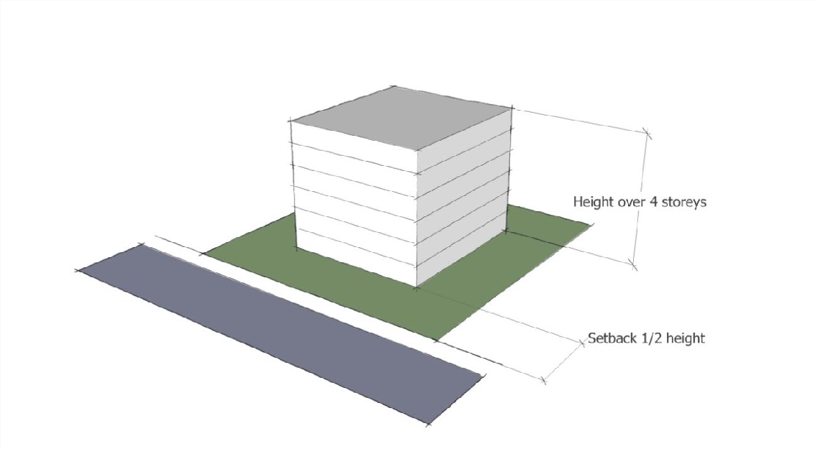
Figure 7.2.3.4.a – Setbacks for buildings greater than four storeys adjacent to a residential zone

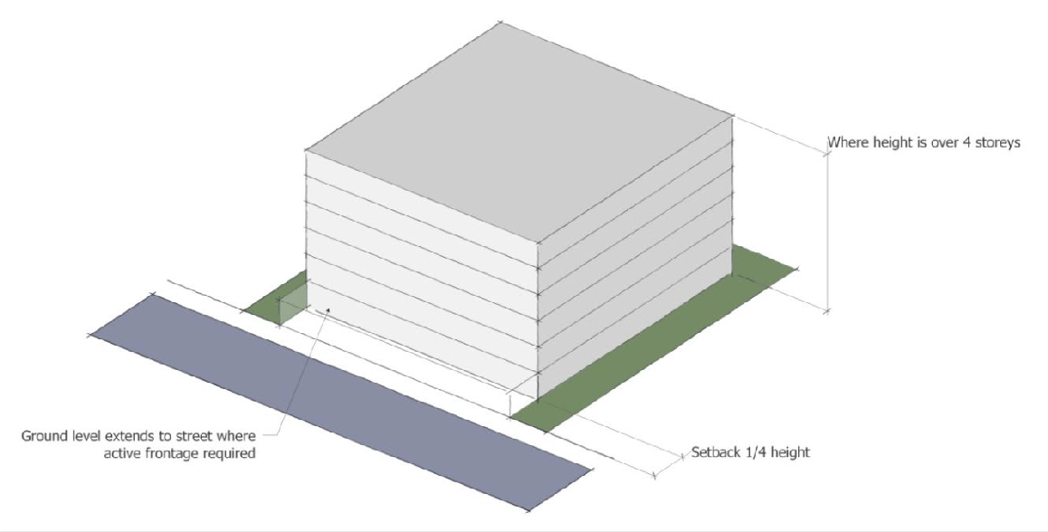

Figure 7.2.3.4.b – Setbacks for buildings greater than four storeys adjacent to a non-residential zone

