Reconfiguring a lot code

Application
- This code applies to assessing a development application for Reconfiguring a lot.

- When using this code, reference should be made to Part 5.

Purpose
- The purpose of the Reconfiguring a lot code is to ensure that development:
  - contributes to a high standard of amenity;
  - results in lots that are suitable for their intended use;
  - results in lots that are orientated to respond to local climatic conditions;
  - is responsive to land constraints;
  - provides lawful and practical access arrangements;
  - provides infrastructure and services to new lots and communities.

- The purpose of the code will be achieved through the following overall outcomes:
  - development results in a well-designed pattern of streets supporting walkable communities;
  - lots have sufficient areas, dimensions and shapes to be suitable for their intended use, taking into account environmental features and site constraints;
  - lot configuration and orientation facilitates climate responsive design;
  - road networks provide connectivity that is integrated with adjoining existing or planned development while also catering for the safe and efficient access for pedestrians, cyclists and for public transport;
  - lots are arranged to front all streets and parkland such that development enhances personal safety, traffic safety, property safety and security; and contributes to streetscape and open space quality;
  - development does not diminish environmental and scenic values;
  - people and property are not placed at risk from natural hazards;
  - a range of functional parkland, including local and district parks, major areas of parkland with a region-wide focus and open space links are available for the use and enjoyment of residents and visitors to the region;
  - the appropriate standard of infrastructure is provided and the potential safety and amenity impacts associated with infrastructure provision are minimised.

Criteria for assessment
Part A - Criteria for assessable development

Table 9.4.8.3.a – Reconfiguring a lot code – assessable development
Performance outcomes | Acceptable outcomes | Applicant response
For assessable development
Lot areas and dimensions
PO1  Lots have areas and dimensions that:  (a) are consistent with the purpose and overall outcomes of the applicable zones or zone;  (b) can accommodate land uses that are consistent with the purpose and overall outcomes of the applicable zone or zones;  (b) are generally rectangular in shape. | AO1.1  Lots comply with the lot reconfiguration outcomes in Table 9.4.9.3.b.
AO1.2
Lots align with zone boundaries.
AO1.3
New lots are generally rectangular in shape with functional areas for land uses intended by the zone.
AO1.4
Boundary angles are not less than 45 degrees.
Climate and site responsive design
PO2  The street design and lot orientation facilitates the construction of energy efficient buildings that respond to the local climate conditions by:  (a) maximising solar access to the north;  (b) minimising the extent of external walls facing to the east and west.  (c) proportioning lots and building envelopes to accommodate energy efficient building orientation;  (d) maximising access to prevailing winds to allow for air-permeability. | AO2.1  The lot design maximises the number of lots where the longest axis of the lot has a general east-west orientation.
AO2.2
The street pattern maximises the number of streets running in a general north-south direction.

PO3  Development responds appropriately to its local context, natural systems and site features. | AO3.1  Existing site features such as:  (a) significant vegetation and trees;  (b) waterways and drainage paths;  (c) vistas and vantage points are retained and/or are incorporated into open space, road reserves, near to lot boundaries or as common property.
Access
PO4  Lots have safe, legal and practical access to a public road. | AO4.1  Each lot is provided with:  (a) direct access to a gazetted road reserve; or  (b) access to a gazetted road via a formal access arrangement registered on the title.
Safety
PO5  Safety of users of the development and the surrounding community is considered and incorporated into the design of the reconfiguration.  Note – Planning scheme policy – Crime prevention through environmental design (CPTED) provides guidance on appropriate design responses. | AO5.1  No acceptable outcomes are provided.
Additional requirements for lots that are capable of further reconfiguration
PO6  New lots that are of a size or shape capable of further reconfiguration are designed so the further reconfiguration will achieve:  (a) sufficient area and dimensions to accommodate the appropriate intended land use;  (b) the provision of a safe, efficient and effective infrastructure network;  (c) limited proportions of rear allotments. | AO6.1  The ability to further reconfigure the site is demonstrated by submitting a concept plan that meets requirements for the applicable zone.
Additional requirements for the retention of existing buildings and structures
PO7  Where existing buildings or structures are to be retained, development results in:  (a) boundaries that offer rectangular lot shapes and usable spaces;  (b) existing improvements complying with current building and amenity standards in relation to boundary setbacks.  Note – This may require buildings or structures to be modified, relocated or demolished to meet setback standards, resolve encroachments and the like. | AO7.1  Development ensures setbacks between existing buildings or structures and proposed boundaries satisfy relevant building standards or zone code requirements, whichever is the greater.
Additional requirements for the creation of rear lots
PO8  Where rear lots are proposed, development:  (a) provides a high standard of amenity for residents and other users of the site and adjoining properties;  (b) positively contributes to the character of adjoining properties and the area;  (c) does not adversely affect the safety and efficiency of the road from which access is gained. | AO8.1  Where rear lots are proposed:  (a) the minimum area of the rear lot, exclusive of any access strip, complies with the lot reconfiguration outcomes in Table 9.4.9.3.b;  (b) no more than 2 rear lots are located at the end of a cul-de-sac street;  (c) rear lots are generally rectangular in shape;  (d) no more than one rear lot is created behind any lot with a road frontage;  (e) access strips to the rear lot are located on only one side of the front lot;  (f) not more than 2 access strips to rear lots directly adjoin one another.  Note – Figure 9.4.9.3.a provides guidance on meeting the outcomes.
AO8.2
Access strips are a minimum width of:
(a) 4.0 metres in a Residential zone;
(b) not less than 8.0 metres in all other zones.

Note – Rear lots a generally not appropriate in non-Residential or non-Rural zones.

Note – Refer to the definition of Residential zones contained in Schedule 1.2.
Additional requirements for development within a Centre zone
PO9  Lot reconfiguration within a Centre zone results in a layout of lots that reinforce:  (a) a mix of adaptive buildings and continued centre activity uses;  (b) large, rectangular shaped lots;  (c) accessibility across land within the zone to key public transport and public places on adjacent roads and land.  Note – Refer to the definition of Centre zone contained in Schedule 1.2. | AO9.1  No acceptable outcomes are provided.
Additional requirements for development involving cane rail infrastructure
PO10  Development protects the cane rail network to support the on-going operation of the agricultural industry. | AO10.1  No acceptable outcomes are provided.  Note – The cane rail network is shown on the Strategic framework maps and Transport network overlay maps contained in Schedule 2.
Additional requirements for development on or adjacent to land within the rural zone
PO11  Lot reconfiguration on or adjacent to land within the Rural zone, provides an appropriate separation area on site to buffer development from impacts arising from uses which may occur on the land within the Rural zone. | AO11.1  No acceptable outcomes are provided.
Additional requirements for rear laneways
PO12  Rear laneways in residential subdivisions are designed to:  (a) limit vehicular access to the lot via the laneway;  (b) provide good passive surveillance along and across the rear laneway;  (c) avoid continuous lines of garages and carports along the length of the rear laneway;  (d) establish appropriately orientated lots;  (e) discourage non-resident vehicular access. | AO12.1  Where rear laneways are used in residential subdivisions, they are designed to:  (a) be on a general north-south axis to avoid producing lots that have a long axis on an east-west orientation thereby minimising excessive heat from afternoon sun;  (b) are no longer than 100 metres in length;  (c) are not the primary access point for emergency vehicles;  (d) include design treatments at either end to design a low speed environment;  (e) maintain straight sightlines.
Additional requirements for the creation of small residential lots
PO13  Small residential lots are designed to a high standard of amenity for future communities and residents and the provision of a range of housing types. | AO13.1  Small residential lots are designed with a road frontage not less than 12 metres.
AO13.2
Small lots are located and designed to ensure:
(a) vehicle parking areas are not a dominant feature of the future dwelling house and streetscape;
(b) they are located adjacent to high amenity features of neighbourhoods (such as public open space or natural areas);
(c) they are not the dominant lot type in neighbourhoods;
(d) they avoid being located in clusters of more than 8 having the frontage to the same street.
AO13.3
Small lots are generally not less than 350m² except where design conditions can ensure that small lots meet AO13.2 and can also:
(a) provide for consistently designed and managed attached housing on individual lots; or
(b) ensure dwelling houses can be managed through building envelopes; or
(c) provide access to the rear of the lot by a laneway.
Additional neighbourhood design requirements for:
a) a site included within the Emerging community zone; or
(b) a site which is more than 5,000m² in any of the Residential zones; or
(c) development involving the creation of new roads and/or public use land.

This part also applies to any application made under Section 242 of the Sustainable Planning Act which will involve, or enable future, lot reconfiguration.

Note – This part is to be read in conjunction with the other parts of the code
Note – Refer to the definition of Residential zones contained in Schedule 1.2.
PO14  Development establishes a structured neighbourhood that provides for:  (a) integration with existing urban areas;  (b) the growth of new communities with different lot layouts and neighbourhood blocks that provide for different land use intents over time;  (c) a range of community infrastructure, including linear open space links, local open space which is adaptable to a variety of uses;  (d) a network of interconnected roads and pathways which convey and connect local and wider vehicular traffic, public transport and active transport with activity centres, employment areas and focal points within communities;  (e) a network of essential infrastructure including water, sewerage, electricity and telecommunications.  Note – A detailed structure plan prepared in accordance with Planning scheme policy – Structure planning is one way of demonstrating compliance with the performance outcomes. | AO14.1  No acceptable outcomes are provided.
PO15  Neighbourhood design results in a safe and connected network of walkable neighbourhoods. | AO15.1  Neighbourhood street networks provide an easy choice of routes within and to surrounding neighbourhoods, and connect to public transport, employment, open space and services.
AO15.2
Development does not establish cul de sac streets unless:
(a) cul-de-sacs are a feature of the existing pattern of development in the area;
(b) there is a physical feature or incompatible zone change that dictates the need to use cul de sac streets.
AO15.3
Where a cul de sac street is used, it:
(a) is designed to be no longer than 150 metres in length;
(b) is designed so that the end of the cul de sac is visible from its entrance;
(c) provides connections from the top of the cul de sac to other streets for pedestrians and cyclists with a minimum width of 6 metres.
PO16  Neighbourhood design supports diverse housing choices through block sizes and lot design. | PO16.1  Changes in lot size and frontage widths are established to facilitate a mix of housing choice.
PO17  Neighbourhood design provides for non-residential uses appropriate to the respective zone and are focussed around local or neighbourhood activity centres, open space, community supportive uses and/or public transport. | AO17.1  Development provides opportunities for community facilities, services, public transport stops and parks to establish neighbourhood focal points.
AO17.2
Neighbourhood focal points are located within 400m (measured according to the shortest route that reasonably may be used in travelling) of 90% of the proposed residences in the catchments that they are intended to service.
PO18  Lots surrounding neighbourhood focal points and activity centres are of a size that enables higher residential densities to support the facilities and/or public transport service. | AO18.1  No acceptable outcomes are provided.
PO19  Provision of physical and social infrastructure in developing residential neighbourhoods is facilitated through the orderly and sequential development of land. | AO19.1  No acceptable outcomes are provided.
PO20  Development provides land to:  (a) meet the recreation needs of the community;  (b) provide an amenity commensurate with the structure of neighbourhoods and land uses in the vicinity and adjacent to open space areas;  (c) provide for green corridors and linkages. | AO20.1  No acceptable outcomes are provided.
PO21  Lot reconfiguration integrates major electricity infrastructure and substations within the overall neighbourhood layout. In particular, the neighbourhood design:  (a) ensures land of sufficient size and suitability is allocated to accommodate the existing and future electricity infrastructure network;  (b) as far as possible, minimises the likely visual prominence of electricity infrastructure;  (c) provides for an interface or relationship with surrounding uses that minimises the potential for nuisance, health and safety concerns. | AO21.1  No acceptable outcomes are provided.
PO22  Major electricity infrastructure on private land is contained within an easement that satisfies the electricity provider’s requirements. | AO22.1  Existing easements for major electricity infrastructure are retained.  or  AO22.2  Where major electricity infrastructure is not contained within an easement, new easements are created that satisfy the electricity provider’s requirements.
PO23  Lot size, dimensions, frontage and orientation permits buildings to be established that will facilitate casual surveillance to open space. | AO23.1  Open space is regular in shape.
AO23.2
At least 50% of the open space’s frontage is provided as road.
AO23.3
Open space areas are positioned to be capable of being overlooked by surrounding development.

Note – Figure 9.4.9.3.b provides guidance on meeting the outcomes.
AO23.4
Surrounding lots are orientated so that facades will front and overlook the urban parkland and other open space.

Note – Figure 9.4.9.3.b provides guidance on meeting the outcomes.
AO23.5
The number of lots that back onto the urban parkland and other open space is minimised.

Note – Figure 9.4.9.3.b provides guidance on meeting the outcomes.
PO24  Development provides a street pattern that caters for the extension of public transport routes and infrastructure including safe pedestrian pick-up and set-down facilities. | AO24.1  No acceptable outcomes are provided.
PO25  Private subdivisions (gated communities) do not compromise the establishment of connected and integrated infrastructure and open space networks. | PO25.1  No acceptable outcomes are provided.
PO26  The function of new roads is clearly identified and legible and provides integration, safety and convenience for all users.  Note – The design and construction standards are set out in Planning scheme policy – FNQROC Regional Development Manual, with reference to the specifications set out in Sections D1 and D3. | AO26.1  No acceptable outcomes are provided.
PO27  Street design supports an urban form that creates walkable neighbourhoods and the design:  (a) is appropriate to the function(s) of the street;  (b) meets the needs of users and gives priority to the needs of vulnerable users. | AO27.1  No acceptable outcomes are provided.

Table 9.4.9.3.b – Lot reconfiguration outcomes
Zone | Minimum lot sizes | Minimum width and dimension
Community facilities | No minimum lot size or road frontage is provided.
Conservation | No minimum lot size or road frontage is provided.  Note – Lot reconfiguration in the Conservation zone results in no additional lots, except where associated with a lease exceeding 10 years and associated with an existing or approved Telecommunications facility. The Conservation zone code contains additional lot reconfiguration outcomes.
District centre | No minimum lot size or road frontage is provided.  Note – The District centre zone code contains additional lot reconfiguration outcomes.
Emerging community | 40ha  or  As identified within an approved structure plan. | 250m  or  As identified within an approved structure plan.
Environmental management | No minimum lot size or road frontage is provided.  Note – Lot reconfiguration in the Environmental management zone results in no additional lots, except where associated with a lease exceeding 10 years and associated with an existing or approved Telecommunications facility. The Environmental management zone code contains additional lot reconfiguration outcomes.
High impact industry | 2000m² | 40m
Local centre | No minimum lot size or road frontage is provided.  Note – The Local centre zone code contains additional lot reconfiguration outcomes.
Low density residential | 600m² | 15m
Low impact industry | 800m² | 20m
Low-medium residential | 450m²  or  350m² (where compliant with the small residential lot provisions of this code) | 12m
Major centre | No minimum lot size or road frontage is provided.
Medium density residential | 600m² | 15m
Medium impact industry | 1000m² | 20m
Mixed use | 800m² | 20m
Neighbourhood centre | No minimum lot size or road frontage is provided.  Note – The Neighbourhood centre zone code contains additional lot reconfiguration outcomes
Open space | No minimum lot size or road frontage is provided.
Principal centre | No minimum lot size or road frontage is provided.
Rural residential | 4,000m², incorporating:  (a) a minimum of 2000m² which is exclusive of land with slopes exceeding 1 in 4 (25%);  (b) a minimum dimension of 30 metres;  (c) sufficient area to cater for on-site waste water management systems.  or  2,000m² (where serviced by reticulated sewerage infrastructure and adjoining land within a Residential zone.  Note – refer to the definition of Residential zones contained in Schedule 1.2. | 30m
Rural | 40ha, unless:  (a) the reconfiguration results in no additional lots (e.g. amalgamation, boundary realignments to resolve encroachments); or  (b) the reconfiguration is limited to one additional lot created to accommodate:  (i) an emergency services facility; or  (ii) water cycle management infrastructure; or  (iii) waste management facility; or  (iv) telecommunications infrastructure. | 250m
Special purpose | No minimum lot size or road frontage is provided.
Specialised centre | No minimum lot size or road frontage is provided.
Sport and recreation | No minimum lot size or road frontage is provided.
Tourism | No minimum lot size or road frontage is provided.
Tourist accommodation | 800m² | 20m
Township | 600m² | 15m
Waterfront and marine industry | 1000m² | 20m

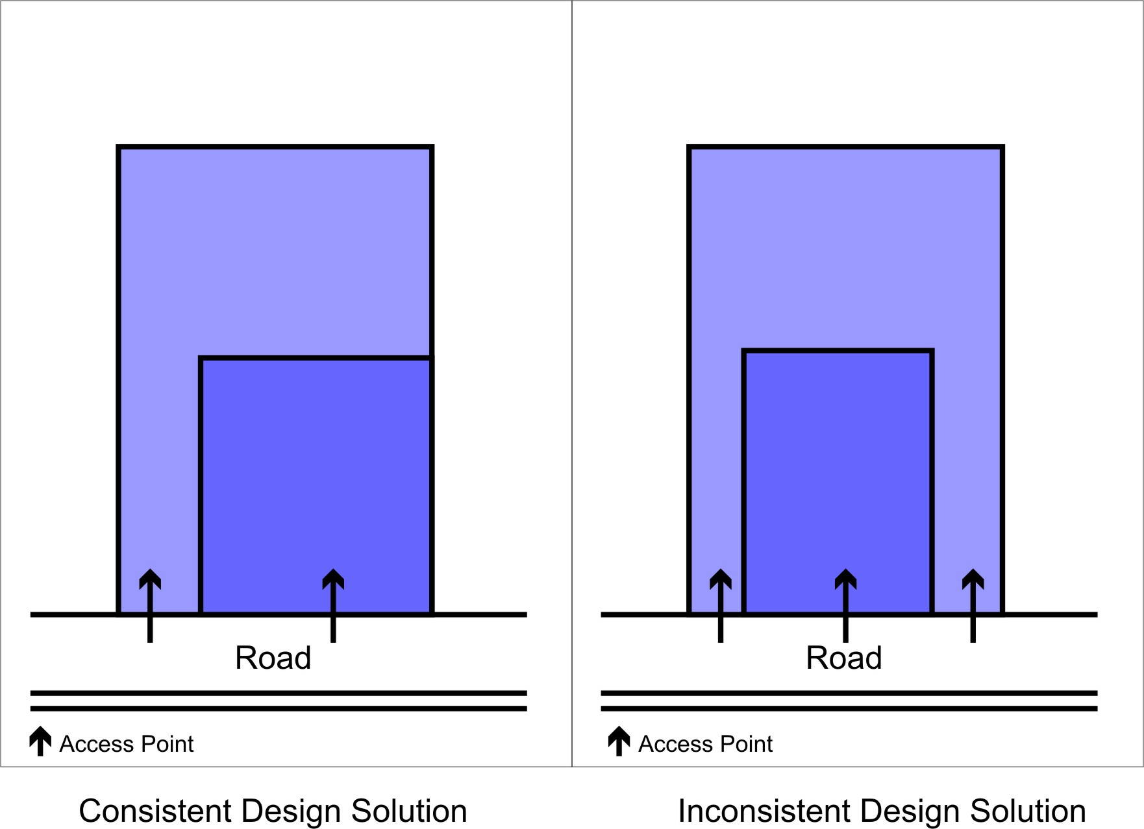

Figure 9.4.9.3.a – Design solutions for access

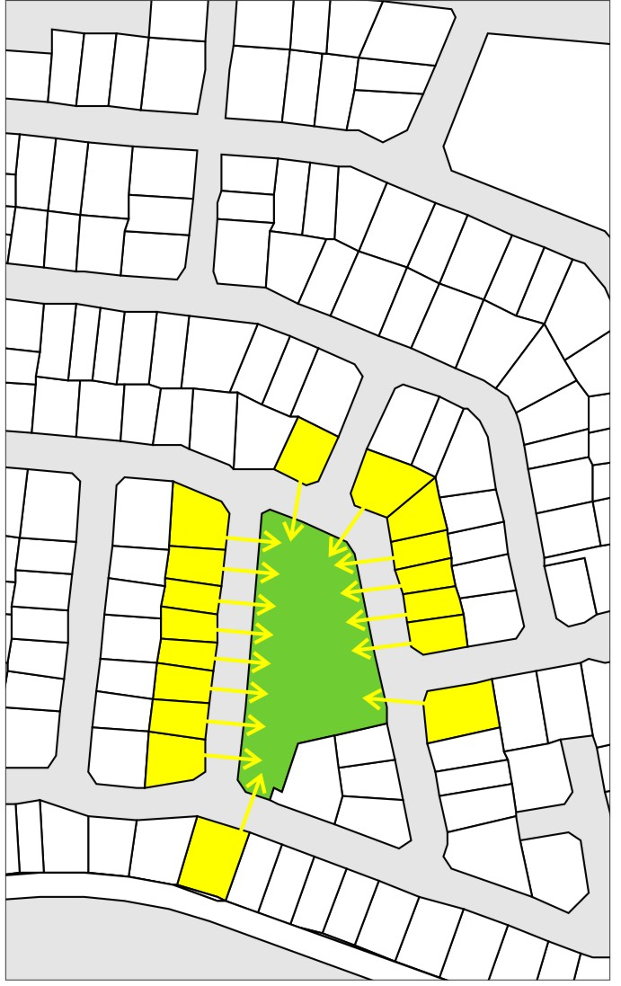

Figure 9.4.9.3.b – Consistent design solution for the orientation of lots surrounding open space and parkland

This is the minimum width of the lot measured at any point and the minimum dimension of any boundary. This excludes access strips.

