Dwelling house code

Application
- This code applies to assessing development for Dwelling houses where located within the following zones:
  - Low density residential zone;
  - Low-medium density residential zone;
  - Medium density residential zone;
  - Rural residential zone;
  - Tourist accommodation zone, excluding Tourist accommodation zone precinct 1 - Islands.

- When using this code, reference should be made to Part 5.
Note - This code applies to Dwelling houses, including ancillary buildings and structures (e.g. Garages, carports, sheds, extensions, secondary dwellings, retaining walls and swimming pools).

Purpose
- The purpose of the Dwelling house code is to ensure that development is appropriately located and designed to the features and characteristics of the site, the streetscape and surrounding area.

- The purpose of the code will be achieved through the following overall outcomes:
  - development is appropriately designed and sited to be consistent with the intended character and amenity of the streetscape and surrounding area;
  - development is appropriately integrated with the existing built and natural features of the site, the streetscape and surrounding area;
  - a secondary dwelling is subordinate in size, scale and use to the primary dwelling;
  - the design, siting and location of retaining walls:
    - do not result in adverse visual impacts;
    - maintains the amenity, privacy and function of the site or adjoining premises;
  - infrastructure provision meets the needs of development, is safe and efficient and is provided to the relevant standard;
  - access and driveways are designed and constructed:
    - to be convenient and accessible;
    - so that they do not adversely impact on the safety and efficiency of the surrounding road network;
    - to minimise adverse impacts to on-street parking arrangements within the road reserve fronting the site;
    - where within a Neighbourhood character area, to be consistent with, and complementary and responsive to the Neighbourhood character elements displayed on the Neighbourhood character place, within the Neighbourhood character streetscape and the Neighbourhood character area;
    - where within the Places of significance overlay, is complementary to the cultural significance of the place;
  - Where development is located within an ANEF Contour area identified on the Airport environs overlay maps contained in Schedule 2, development is compatible with forecast levels of aircraft noise to avoid conflicts between the Cairns Airport and surrounding land uses;
  - Where development is located within an area identified on the Bushfire hazard overlay maps contained in Schedule 2, development mitigates the risks of bushfire hazard to people and property;

  - Where development is located within an area identified on the Flood and inundation hazard overlay maps contained in Schedule 2 development:
    - maintains the safety of people and property;
    - minimises the exposure of people and property to unacceptable risk;
    - is designed, located and operated to minimise damage to property, disruption to building function and the re-establishment time after a flood or storm tide event;
    - does not directly or cumulatively cause or increase adverse impacts of flood or storm tide hazard on other properties or require complex engineering solutions to mitigate adverse impacts.
    - in Precinct 3 – CBD and environs ensures development results in no loss of planned floodplain storage.
  - Where development is located within a Hillslopes area identified on the Hillslopes overlay maps contained in Schedule 2, it:
    - is safe, serviceable and accessible;
    - protects the landscape character and scenic amenity to retain the scenic backdrop to the region;
    - is appropriate, having regard to the topographic constraints and environmental characteristics of the land.

  - Where development is located within a MLES - Waterway trigger area identified on the Natural areas overlay maps contained in Schedule 2:
- development is avoided within waterways and waterway corridors;
- where development cannot be avoided, development:
  - protects and enhances areas of environmental significance;
  - provides appropriate buffers to areas of environmental significance;
  - ensures that adverse direct or indirect impacts on areas of environmental significance are minimised through design, siting, operation, management and mitigation measures;
  - protects and maintains ecological and hydrological functions of waterways and waterway corridors.
  - Where development is located within a Potential landslip hazard area identified on the Potential landslip hazard overlay maps contained in Schedule 2, development is located, designed and constructed to mitigate the risk to people and property to an acceptable or tolerable level.

Assessment benchmarks and requirements
Table 9.2.10.3.a – Dwelling house code –assessment benchmarks and requirements for accepted development
Performance outcomes | Acceptable outcomes | Applicant response
For accepted development subject to requirements and assessable development
Secondary dwellings
PO1  Secondary dwellings:  - are small-scaled dwellings that are subordinate to the primary dwelling;  - contribute to a safe and pleasant living environment;  - do not cause adverse impacts on adjoining properties. | AO1.1  The secondary dwelling has a GFA, exclusive of a single carport or garage, of not more than 70m2.
Retaining Walls
Amenity
PO2  Retaining walls:  - do not have an adverse impact on the amenity, privacy or function of the site or adjoining premises;  - do not result in a dwelling losing access to sunlight;  - are not visually intrusive or overbearing where viewed from surrounding areas and adjoining premises;  - incorporate landscaping to visually soften built form elements;  - avoid excessive changes to the natural landform, including vegetation, as a result of the location, position on site, scale, design, extent and alignment;  - avoid adverse impacts on landscape values; | AO2.1  Retaining walls do not exceed 1.8 metres in height.
AO2.2
Where within a Hillslopes area identified on the Hillslopes overlay maps contained in Schedule 2, retaining walls do not exceed 20 metres in cumulative length, where not incorporated within a level change within a building.

(g) where within a Hillslopes area identified on the Hillslopes overlay maps contained in Schedule 2, avoid adverse impacts on landscape values to the scenic amenity quality of the hillslopes areas.
Access, Driveway and Infrastructure works
Access & Driveway
PO3  Access is designed and constructed:  - to operate safely and efficiently;  - to accommodate the anticipated type and volume of vehicles;  - so that they do not impede the safe movement of vehicles, cyclists or pedestrians on the adjacent road area or verge;  - so that they do not adversely impact upon existing intersections or future road or intersection improvements;  - so that they do not adversely impact current and future on-street parking arrangements;  - so that they do not adversely impact upon existing services within the road reserve adjacent to the site;  - where within a Neighbourhood character area, to be consistent with, and complementary and responsive to the Neighbourhood character elements displayed on the Neighbourhood character place, within the Neighbourhood character streetscape and the Neighbourhood character area;  - where within the Places of significance overlay, is complementary to the cultural significance of the place. | AO3.1  For development for a Dwelling House where located within the Neighbourhood Character Overlay or the Places of Significance Overlay access is limited to one access per lot that is:  - an existing access; or  - a new access that:  - is from the lower order road where there is more than one frontage to the site;  - has a maximum width of 3m;  - unless where located within the Rural Residential Zone, is imperviously sealed.  Note - Imperviously sealed includes, but is not limited to, concrete, asphalt or concrete pavers. Where concrete is used, construction is in accordance with Planning scheme policy – FNQROC Regional Development Manual S7 – Concrete Works and Standard Drawing S1015.  or  AO3.2  For development for a Dwelling House, where not located within the Neighbourhood Character Overlay or the Places of Significance Overlay, provides for access to the lot that is:  - an existing access; or  - a new primary access that:

- is from the lower order road where there are more than one frontage to the site;
- has a maximum width of 5.5m;
- unless where located within the Rural Residential Zone, is imperviously sealed.
- a secondary access, where:
  - development is on a lot that has a minimum road frontage of 18m to, and access is being provided to the lot from, an Access Road;
  - the access has a maximum width of 3m;
  - the secondary access is separated by a minimum of 5.5m from the primary access;
  - unless where located within the Rural and Rural Residential Zone, is imperviously sealed.

Note – Imperviously sealed includes, but is not limited to, concrete, asphalt or concrete pavers. Where concrete is used, construction is in accordance with Planning scheme policy – FNQROC Regional Development Manual S7 – Concrete Works and Standard Drawing S1015.

Note – access is for vehicular access and includes access crossovers and driveways.

AO3.3
Access is designed, located and constructed to:
- achieve the following minimum clearances:
  - 600mm from stormwater infrastructure;
  - 500mm from street signage;
  - 500mm from electrical pillars;
  - 1m from parking metres;
  - 1m from power or light poles;
  - 1m clear of existing trees (measured from the tree trunk);
  - 6m from the tangent point of any intersection; and
- provide for a connection to any existing pathway located in the road verge either side of the access.

Note – access is for vehicular access and includes access crossovers and driveways.
AO3.4
The crossfall of a driveway over the road verge:
- must not exceed 2.5%; or
- where the existing crossfall of the road verge exceeds 2.5% in any direction, the driveway does not alter the crossfall of the verge.
AO3.5
Driveways are:
- designed to follow as close as possible to the existing contours but are no steeper than the gradients outlined in Planning scheme policy – FNQROC Regional Development Manual;
- constructed such that where there is a grade shift to 1 in 4 (25%), there is an area with a grade of no more than 1 in 6 (16.6%) prior to this area, for a distance of at least 5 metres;
- on gradients greater than 1 in 6 (16.6%) driveways are constructed to ensure that the

crossfall of the driveway is one-way and directed into the hill, for vehicle safety and drainage purposes;
- constructed such that the transitional change in grade from the road to the lot is fully contained within the lot and not within the road reserve;
- designed to include all necessary associated drainage that intercepts and directs storm water runoff to the road, storm water drainage system.
Water supply
PO4  Development provides an adequate, safe and reliable supply of potable, firefighting and general use water. | AO4.1  Development provides a connection to Council’s reticulated water supply system, that is:  - an existing connection; or  - a connection provided in accordance with the relevant standards contained in Planning Scheme Policy – FNQROC Regional Development Manual;  or  AO4.2  Where a reticulated water supply system is not available to the premises, an on-site water storage tank/s with a minimum capacity of 30,000 litres and access to the tank/s for fire trucks is provided for each new dwelling.
Wastewater
PO5  Development provides for adequate treatment and disposal of wastewater. | AO5.1  Development provides a connection to Council’s reticulated wastewater system, that is;

- an existing connection; or
- a connection provided in accordance with the relevant standards contained in Planning Scheme Policy – FNQROC Regional Development Manual;

or

AO5.2
Where a reticulated wastewater system is not available to the premises, an on-site sewage facility or an environmentally relevant on-site sewage facility for treating and disposing sewage produced on the premises is provided in accordance with the requirements of the Plumbing and Drainage Act 2018 and the relevant standards contained in Planning Scheme Policy - FNQROC Regional Development Manual.

Additional requirements for development located within an ANEF Contour area identified on the Airport environs overlay maps contained in Schedule 2
Acoustic treatment for noise exposure
PO6  Development is appropriately located and designed to prevent adverse impacts from aircraft noise.  Note - Where the acceptable outcomes cannot be met, a Noise Assessment Report prepared by an appropriately qualified acoustic consultant must be prepared to demonstrate compliance with this performance outcome. | AO6.1  Development is not located within the 25-30, 30-35 and 35-40 ANEF Contour as identified on the Airport environs overlay – Australian Noise Exposure Forecast (ANEF) Contours map contained in Schedule 2;  or  AO6.2  Development is located within the 20-25 ANEF Contour as identified on the Airport environs overlay  – Australian Noise Exposure Forecast (ANEF) Contours map contained in Schedule 2 and is designed and constructed to achieve the following indoor design sound levels:  - 50 dB(A) for sleeping areas;  - 55 dB(A) for all other habitable areas.  or  AO6.3  Development is for an extension to a Dwelling house where:  - the extension does not exceed 50% of the GFA of the existing dwelling house; or  - does not increase site cover of the existing dwelling house.  Note – Figure 9.2.10.3.b, Figure 9.2.10.3.c and Figure 9.2.10.3.d. provides guidance on meeting AO6.3 (a).  Note – Figure 9.2.10.3.e provides guidance on meeting AO6.3 (b).

Additional requirements for development located within an area identified on the Bushfire hazard overlay maps contained in Schedule 2
Note – This section does not apply to Building works applications. Building work is assessable under the relevant Building Assessment Provisions and not this planning scheme. Refer to section 1.6 of this planning scheme.
Note – For the purposes of the Building Code of Australia and AS3959 Construction of Buildings in Bushfire-Prone Areas the land identified within the Bushfire overlay is designated as a bushfire prone area.
Safety of people, property and the environment
PO7  Development mitigates the risks of bushfire hazard to people and property to an acceptable or tolerable level.  Note – Where an alternative acceptable outcome is proposed to demonstrate compliance with the performance outcome, a bushfire hazard assessment should be prepared in accordance with the QFES Bushfire resilient communities document. The bushfire hazard assessment should include a site-level verification of the location and nature of hazardous vegetation and resulting potential bushfire intensity levels.  Note – The design and siting of development must ensure that any required firebreaks or setback to achieve separation from vegetation is accommodated on the lot it serves.  Note – Where development is also located within the Natural areas overlay and/or the Hillslopes overlay, the siting of the development must consider the impacts of any vegetation damage required for the establishment of firebreaks or to achieve separation from vegetation. | AO7.1  Development is not located in an area of Potential impact buffer or Medium, High or Very high potential bushfire intensity area.  or  AO7.2  Development is located on a lot less than 2000m2 within a Residential zone.  Note – Refer to the definition of Residential zone within Schedule 1.2.
Additional requirements for Material change of use or Building work located within an area identified on the Flood and inundation hazards overlay maps contained in Schedule 2 as a Storm tide inundation hazard area or an Inundation hazard area.
Note – The Flood and Inundation hazards overlay maps contained in Schedule 2 identify areas (flood and inundation areas) where flood and storm tide inundation modelling has been undertaken by Council. Other areas not identified by the Flood and inundation hazards overlay maps contained in Schedule 2 may also be subject to a Flood or inundation event.

The mapping data source for the Floodplain assessment precinct is very broad and is a high level default mapping product required by State policy to be reflected in areas where the inundation level of the defined hazard event has not been determined through appropriate flood studies. The map is provided to ensure that the risk of inundation is assessed and mitigated when development is proposed in these areas.
PO8  Development is located and designed to:  - ensure the safety of all persons;  - minimise damages to the development and contents of buildings; | AO8.1  Development is sited on parts of the land that is not within an area as shown on the Flood and inundation hazards overlay maps contained in Schedule 2;

- provide suitable amenity;  - minimise disruption to residents, recovery time, and rebuilding or restoration costs after inundation events. | or  AO8.2  Development is designed and constructed to provide immunity to the Defined Inundation Event level as listed below, plus a freeboard of 300mm:  - Dwelling house – 1% AEP Defined inundation event level (Minimum immunity to be achieved (floor levels)).  Note – Relocation of a Dwelling house must ensure that habitable floors are located 300mm above the 1% AEP Defined inundation event level even where they may have been previously located below the 1% AEP level.  - Class 10 structures – No specified immunity.  Editor’s Note – It is recommended, but not mandatory, that carports and garages attached to a Dwelling house are located at or above the 5% AEP Defined inundation event level, to minimise the risk of property damage in an inundation event.  Editor’s Note – It is recommended, but not mandatory, that patios, decks and other areas (including non-habitable parts of a Class 1 building) attached to a Dwelling house are located above the 1% AEP Defined inundation event level to avoid risk of property damage and ensure safety of people in an inundation event.  - Additions to a Dwelling house where the additions do not exceed 50% of the floor area of the existing building and / or do not include building underneath - No specified immunity.  Note – This does not apply to a Dwelling house where raising or lifting is required to build underneath an elevated building (e.g. Dwelling house of posts, or creation of a two storey building). Where new habitable floor area is to be established underneath an existing Dwelling house (which is already elevated above the ground – e.g. house on posts), the habitable floor area must be located above the 1% AEP level.

Additional requirements for development within Precinct 3 – CBD and Environs as identified on the Flood and Inundation hazards overlay contained in Schedule 2
Note – The Flood and Inundation hazards overlay maps contained in Schedule 2 identify areas (flood and inundation areas) where flood and storm tide inundation modelling has been undertaken by Council. Other areas not identified by the Flood and inundation hazards overlay maps contained in Schedule 2 may also be subject to a Flood or inundation event.

The mapping data source for the Floodplain assessment precinct is very broad and is a high level default mapping product required by State policy to be reflected in areas where the inundation level of the defined hazard event has not been determined through appropriate flood studies. The map is provided to ensure that the risk of inundation is assessed and mitigated when development is proposed in these areas.
PO9  Development in Precinct 3 – CBD and environs ensures filling is not more than the planned loss of flood storage capacity. | AO9.1  Development within Sub-precinct Zone 2 of Precinct 3 – CBD and environs as shown on the Flood and inundation hazards overlay maps contained in Schedule 2 retains a minimum 40% of the flood storage of the site.
Additional requirements for development located within a Hillslopes area identified on the Hillslopes overlay maps contained in Schedule 2
Note – For accepted development, building work triggered by 1.8(1) must be referred to the local government as a concurrence agency and will be assessed against the criteria within Table 1.8.a.
PO10  The landscape character and scenic amenity quality of hillslopes areas is retained to protect the scenic backdrop to the region. | AO10.1  Excavation and filling does not exceed 50m3.
AO10.2
The development does not require or result in vegetation damage.
 | Note – Refer to the definition of Vegetation damage contained in Schedule 1.2.
AO10.3
Development, excluding retaining walls, does not occur on land with a gradient in excess of 1 in 6 (16.6%).

Additional requirements for development located within a MLES - Waterway trigger area identified on the Natural areas overlay maps contained in Schedule 2
Development within the MLES - Urban waterways A trigger area
PO11  Development is set back from the Urban waterway A to protect and maintain:  - water quality;  - hydrological functions;  - ecological processes;  - biodiversity values;  - riparian and instream habitat values and connectivity;  - instream migration | AO11.1  Development is on a lot within a Residential zone and:  - the subject waterway is contained within an easement, covenant, adjoining reserve for waterway purposes or adjoining land under local government control that has a drainage function;  - the development does not occur within that easement, covenant or adjoining reserve or adjoining land under local government control;  or  AO11.2  Development is on a lot within a Residential zone and is located within a building envelope as identified on a Building Envelope Plan that applies to the land under a condition of a relevant approval;  or  AO11.3  Development is on a lot that is separated from the subject waterway by an existing, constructed road within a dedicated road reserve;  or

AO11.4
Development does not occur on the part of the lot affected by a waterway corridor.

Note – refer to the definition of Residential zone within Schedule 1.2.

Note – Waterway corridor widths are identified within Table 9.2.10.3.b. Figure 9.2.10.3.a shows the location of waterway corridors for a waterway.

Note – Figure 9.2.3.10.f, Figure 9.2.3.10.g, Figure 9.2.3.10.h and Figure 9.2.3.10.i provide guidance on meeting AO11.1, AO11.2, AO11.3 and AO11.4.
Development within the MLES - Urban waterways B trigger area
PO12  Development is set back from the Urban waterway B to protect and maintain:  - water quality;  - hydrological functions;  - ecological processes;  - biodiversity values;  - riparian and instream habitat values and connectivity;  - instream migration. | AO12.1  Development is on a lot where the subject waterway is contained within an easement, covenant, adjoining reserve for waterway purposes or adjoining land under local government control that has a drainage function, and development does not occur within the easement, covenant or adjoining reserve or adjoining land under local government control;  or  AO12.2  Development is on a lot that is separated from the subject waterway by an existing, constructed road within a dedicated road reserve;  or

AO12.3

Development does not occur on the part of the lot affected by a waterway corridor.

Note – Waterway corridors are identified within Table 9.2.10.39.2.10.3.b. Figure9.2.10.3.a shows the location of waterway corridors for a waterway.

Note – Figure 9.2.3.10.f, Figure 9.2.3.10.g and Figure Figure
9.2.3.10.i provide guidance on meeting AO12.1, AO12.2 and AO12.3.
Development within the MLES - Non-urban waterway trigger area
PO13  Development is set back from the Non-urban waterway to protect and maintain:  - water quality;  - hydrological functions;  - ecological processes;  - biodiversity values;  - riparian and instream habitat values and connectivity;  - instream migration | AO13.1  Development is on a lot within a Residential zone and:  - the subject waterway is contained within an easement, covenant, adjoining reserve for waterway purposes or adjoining land under local government control that has a drainage function;  - the development does not occur within that easement, covenant or adjoining reserve or adjoining land under local government control;  or  AO13.2  Development is on a lot within the Rural residential zone and is located within a building envelope as

identified on a Building Envelope Plan that applies to the land under a condition of a relevant approval;

or

AO13.3
Development is on a lot that is separated from the subject waterway by an existing, constructed road within dedicated road reserve;

or

AO13.4
Development does not occur on the part of the lot affected by a waterway corridor.

Note – refer to the definition of Residential zone within Schedule 1.2.

Note – Waterway corridor widths are identified within Table 9.2.10.3.b. Figure9.2.10.3.a. shows the location of waterway corridors for a waterway.

Note – Figures 9.2.3.10.f, Figure 9.2.3.10.g, Figure 9.2.3.10.h and Figure 9.2.3.10.i provide guidance on meeting AO13.1, AO13.2, AO13.3 and AO13.4.

Additional requirements for development located within a Potential landslip hazard area identified on the Potential landslip hazard overlay maps contained in Schedule 2
Note – The Potential landslip hazard overlay shows modelled areas where the factors contributing to landslide potential accumulate to provide a moderate or higher risk if certain factors are exacerbated (e.g. factors include significant vegetation clearing, cutting and filling, changes to soil characteristics, changes to overland water flow, or changes to sub-surface water flow). It shows areas that Council has identified where landslides may occur and where land may be impacted by a landslide but does not mean that landslides will occur or that the land will be impacted by a landslide. Other areas not contained within the potential landslip hazard overlay may sustain landslides or be impacted by landslides and consideration should be given to this issue where appropriate.

Note – This section does not apply to Building work applications.
Safety of people, property and environment

AO14  Development avoids areas of Potential land slip hazard as identified on the Potential landslip hazard overly maps contained in Schedule 2 or where development cannot avoid areas of potential land slip hazard, development does not increase the risk of harm to people or property as a result of landslip hazard. | AO14.1  Development is located on the part of the site that is not affected by the Potential landslip hazard overlay maps contained in Schedule 2;  or  AO14.2  Development is on an existing lawfully benched site and requires no further earthworks;  or  AO14.3  Development is undertaken in accordance with a geotechnical assessment that has been approved by Council as a condition of a relevant development approval;  or  AO14.4  Development has a site specific geotechnical assessment undertaken by a registered and professional engineer in accordance with Australian Geomechanics Society Practice Note Guidelines for Landslide Risk Management 2007 (AGS 2007) that demonstrates that the site is:  - suitable for the development;  - not subject to the risk of landslide activity from hazards both internal to the site and from sloping land above the site and will not increase the risk of landslide on other land.  Note – In accordance with AO14.2, lawfully benched means works that occurred lawfully as accepted development or works that were undertake in accordance with a development approval.

Table 9.2.10.3.b – Widths of waterway corridors for waterways
9.2.10.3 | Waterway corridor width
Urban waterway A | 10 metres on each side of the waterway, measured perpendicular from the top of the high bank.
Urban waterway B | 5 metres on each side of the waterway, measured perpendicular from the top of the high bank.
Non-urban waterway | 25 metres on each side of the waterway, measured perpendicular from the top of the high bank.
Note – Waterway classifications are identified through corresponding waterway trigger areas on the Natural areas overlay maps contained in Schedule 2 and defined in Schedule 1.2. Note – Figure 9.2.10.3.a. shows the location of waterway corridors for a waterway.
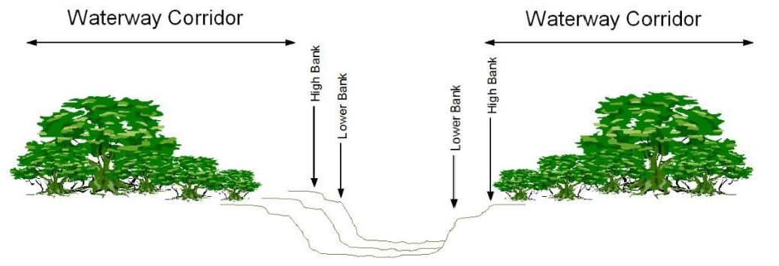

Figure 9.2.10.3.a - Waterway Corridors

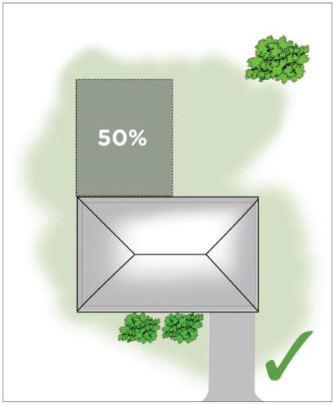

Figure 9.2.10.3.b – Requirements for development in accordance with AO6.3(a)
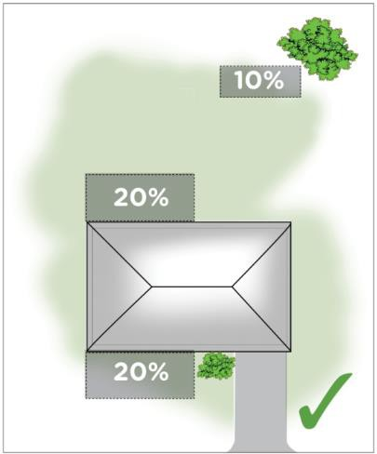

Figure 9.2.10.3.c – Requirements for development in accordance with AO6.3(a)

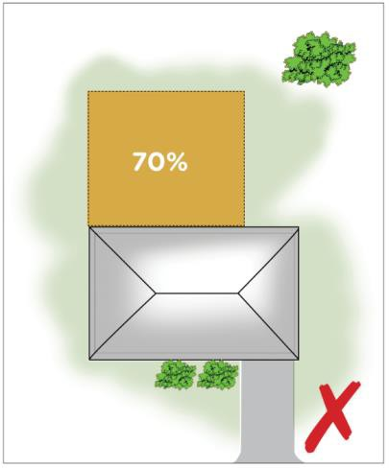

Figure 9.2.10.3.d – Requirements for development in accordance with AO6.3(a)
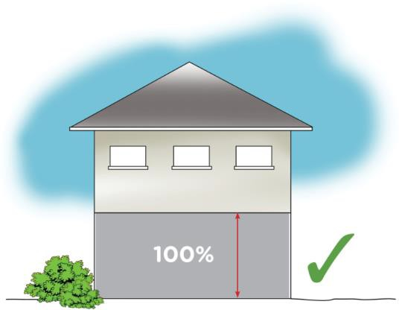

Figure 9.2.10.3.e – Requirements for development in accordance with AO6.3(b)

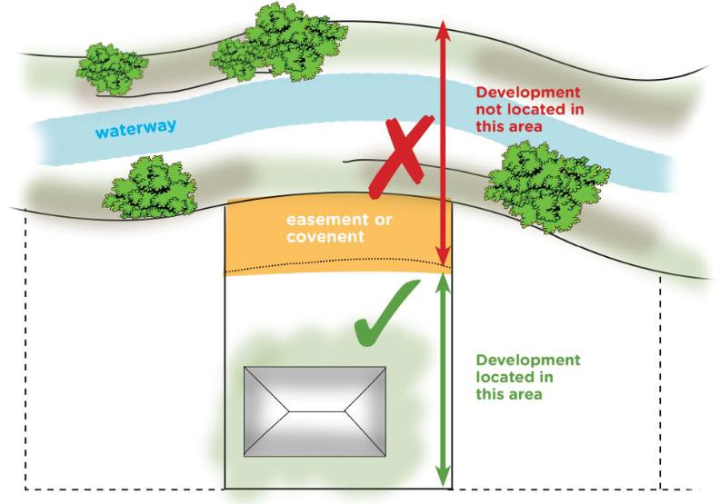

Figure 9.2.10.3.f – Requirements for development in accordance with AO11.1, AO12.1 and AO13.1
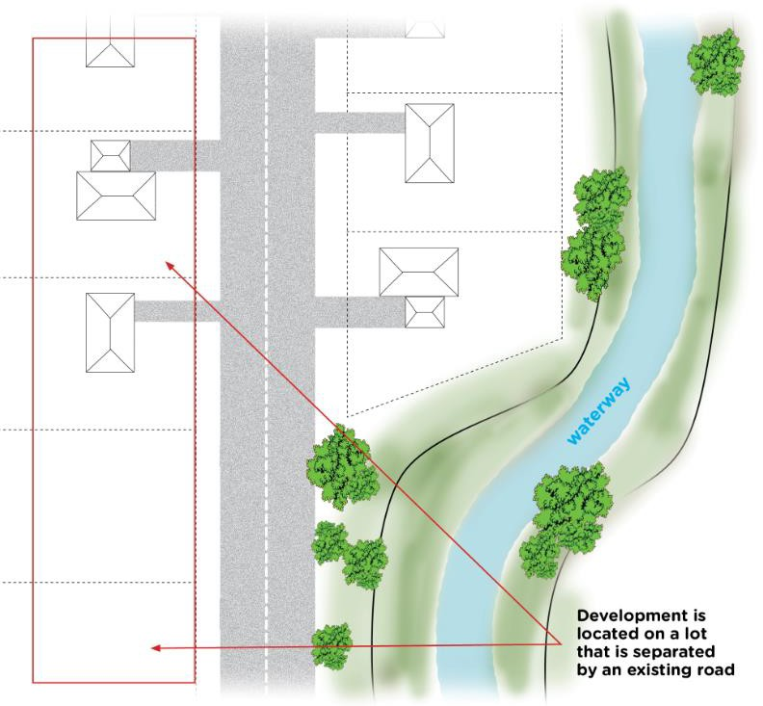

Figure 9.2.10.3.g – Requirements for development in accordance with AO11.3, AO12.2 and 13.3

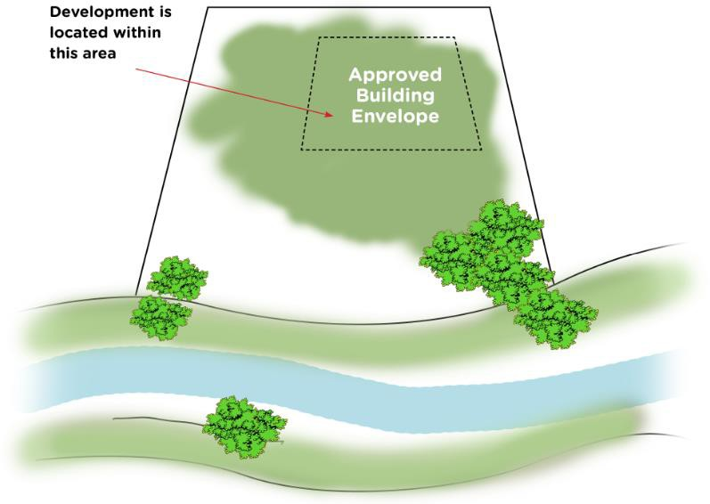

Figure 9.2.10.3.h – Requirements for development in accordance with AO11.2 and AO13.2

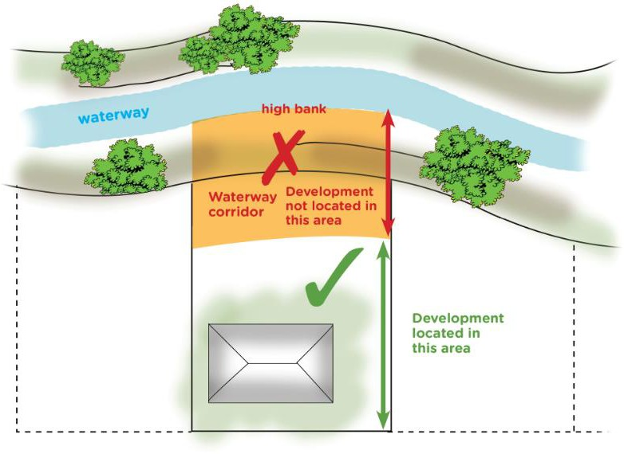

Figure 9.2.10.3.i – Requirements for development in accordance with AO11.4, AO12.3 and AO13.4

