Neighbourhood character overlay code

Application
This code applies to assessing development within the Neighbourhood character overlay.
When using this code, reference should be made to Part 5.

Purpose
- The purpose of the neighbourhood character overlay code is to maintain neighbourhood character places and the existing character elements which contribute to the character of the area and to promote development that is consistent with and sympathetic to the character of the streetscape and neighbourhood character area.

- The purpose of the code will be achieved through the following overall outcomes:
  - neighbourhood character places and existing character elements which contribute to the streetscape and neighbourhood character are retained;
  - the architectural style, height, roof style, building materials, building form and layout, setbacks and orientation of new development is compatible with the existing character elements of the neighbourhood character streetscape and area;
  - extensions or alterations to a neighbourhood character place do not detract from the existing character of the neighbourhood character place or streetscape.

Criteria for assessment

Part A – Criteria for self-assessable and assessable development

Table 8.2.12.3.a – Neighbourhood character overlay code – self-assessable and assessable development
Performance outcomes | Acceptable outcomes | Applicant response
For self-assessable and assessable development
Design and setting
PO1  When viewed from a public place garages, carports, patios, verandahs, balconies and sheds and other ancillary buildings:  (a) are subservient to neighbourhood character place;  (b) are consistent with the neighbourhood character streetscape;  (c) do not detract from the appearance of existing buildings and neighbourhood character elements. | AO1.1  Garages, carports, patios, verandahs, balconies, sheds and other ancillary buildings are located in area A on Figure 8.2.12.3.a;  or  AO1.2  Garages and carports are located wholly under or within an existing building and any associated building works comply with AO3.1;  or  AO1.3  A carport may be located in area B on Figure 8.2.12.3.a where:  (a) a single vehicle carport no greater than 3m in width and height;  (b) it does not have a door to the street frontage.  Note – Height is inclusive of the roof height.
PO2  Fences and driveways complement the traditional building and enhance the overall appearance of the neighbourhood character streetscape. | AO2.1  Fences to road frontages are not more than:  (a) 1.2 metres in height if solid; or  (b) 1.5 metres if partially transparent.
AO2.2
Vehicle access crossovers are not more than 3 metres wide.
Raising, relocating or repositioning of buildings within a site
PO3  Development involving the enclosure of the under storey area of a building:  (a) preserves the dominant visual form of the upper storey;  (b) does not detract from the overall character of the place or the neighbourhood character streetscape.  Note – Planning scheme policy - Neighbourhood character provides guidance on meeting the Performance outcome. | AO3.1  Development of a lower storey is recessed behind the front façade of the upper storey by not less than 1 metre.
PO4  Development involving the raising of buildings on a site:  (a) balances the proportions of the upper and lower storeys;  (b) maintains the streetscape pattern;  (c) does not detract from the character or amenity of the streetscape character. | AO4.1  Development involving the raising of buildings on a site does not reduce the existing front or side boundary setback.
AO4.2
Raising of buildings does not:
(a) increase the height of the lower storey floor level by more than 0.5 metres from ground level;
(b) result in the floor level of the upper storey being more than 3.5 metres from the existing ground level.
For assessable development
Design
PO5  Development on a neighbourhood character place:  (a) does not diminish its character values;  (b) utilises materials that are consistent with the fabric of the neighbourhood character place;  (c) is not obtrusive in the neighbourhood character streetscape;  (d) is consistent with the existing elements of the neighbourhood character area.  Note – Planning scheme policy - Neighbourhood character provides guidance on meeting the Performance outcome. | AO5.1  No acceptable outcomes are provided.
Infill development
PO6  The form, scale and design of development is consistent with, and sympathetic to, the neighbourhood character streetscape and neighbourhood character area, having regard to:  (a) architectural style;  (b) building form and layout;  (c) building orientation;  (d) building alignment;  (e) building materials;  (f) roof style;  (g) building height and scale;  (h) side and rear boundary setbacks;  (i) width (at street frontage);  (j) vertical and horizontal patterning. | AO6.1  Development is consistent with the desired outcomes of the Neighbourhood character area as identified in Planning scheme policy - Neighbourhood Character and is demonstrated through a site assessment and design response.  Note – Planning scheme policy- Neighbourhood character gives guidance on the desired character outcomes and preparing a site assessment and design response.
PO7  Buildings relocated onto a site are of a style and character that is compatible with the neighbourhood character streetscape. | AO7.1  No acceptable outcomes provided.
Demolition or removals
PO8  Development involving demolition or removal of a neighbourhood character place does not occur to retain the streetscape character. | AO8.1  No acceptable outcomes provided.

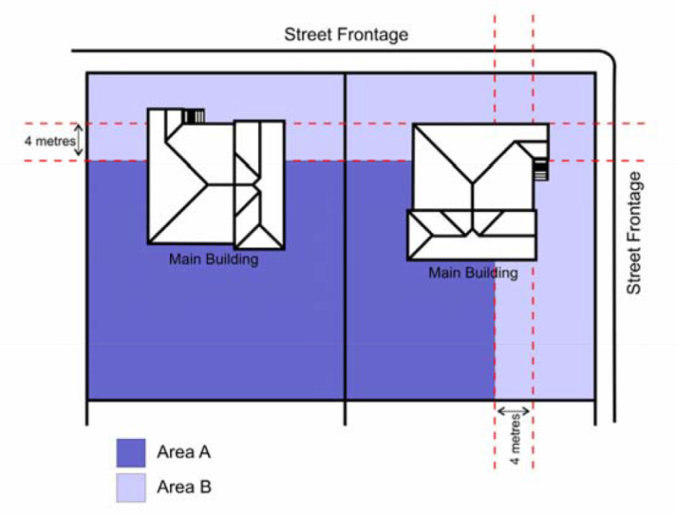
Figure 8.2.12.3.a – Consistent design solutions for carports, sheds and outbuildings

