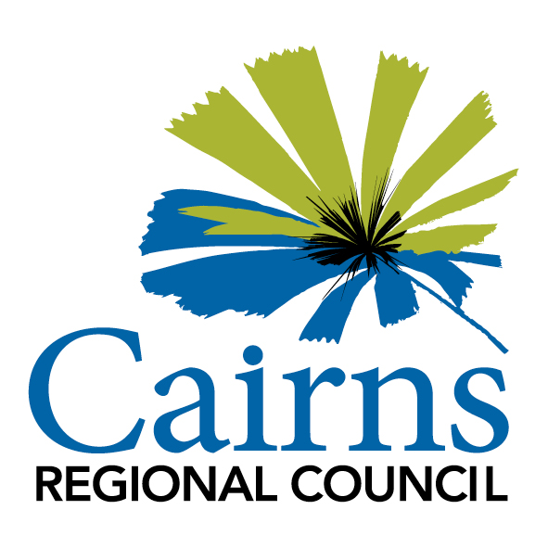

REQUEST FOR QUOTATION

RESPONSE SCHEDULES

YOUTH URBAN ART PROJECT 2022

RFQ NUMBER: 0250

RFQ Closing Time: 5.00PM on Sunday 20 March 2022

PART 6 – RESPONSE FORMS
The Respondent must submit a Response in the form of the Response Schedules attached below:
By submitting this quotation, the Artist acknowledges that the quotation will remain valid and open for acceptance for the timeframe stated in Item 4 of Part 2 (General Information) of the Request for Quotation and that the Respondent has read and understood the terms of the contract referenced in Part 4 (Contract).
Signature of authorised representative of Respondent:
Name of authorised representative of Respondent:

Date: |  | / / 2022
Response Form 1 – GENERAL DETAILS
Legal Entity Name:
Trading or Business Name:
ABN or ACN:
Postal Address:
Street Address:
Contact Person:
Email:
Phone:
Mobile:

Response Form 2 – PRICING
The scale of the project and which elements will be included will be determined by available budget.
It is anticipated that within this project a small site would not exceed $2,000 (ex GST), a medium site would not exceed $12,000 (ex GST) and a large site would not exceed $20,000 (ex GST).

Please itemise expected costs:

Item | Cost  (ex GST) | Comment
Artist fees
Artist fees
Project setup and administration
Design sessions
Consultation sessions (with support from Council).
Support Presentation of concept drawings
Support Presentation of final designs and plans for approval by CRC officer
Application of mural on Mooroobool
Application of mural on Trinity Beach
Application of mural on Woree
Application of mural on Edmonton
Any other expenses
Other fees:
Materials and Preparation: Mooroobool
Materials and Preparation: Trinity Beach
Materials and Preparation: Woree
Materials and Preparation: Edmonton
Insurance
Other expenses
Project total

Response Form 3 – SITE SELECTION
Please indicate which site you are interested in (tick one or all as appropriate):

☐ Ergon padmount transformer- Shang Park, Mooroobool (Renew) map
☐ Gordon Creek cycleway – Woree map
☐ Todd Park - Edmonton map
☐ Coastwatcher Park - Trinity Beach (Table tennis table only) map

Response Form 4 – EVALUATION CRITERIA
Provide a brief biography (approx. 200 words)

Please attach a portfolio or digital images of previous work.

Discuss the consultation, collaboration and design process and how the delivery of the suite of murals will be carried out (See role of Artist) (Under 1000 words)

Please describe your proposed methodology, this should include;
- Consultation process – what steps will be involved in consultation with the local community and its young people to develop proposed artwork. Youth must participate in consultation and provide legitimate suggestions for murals and/ or have a connection to the location.
- Collaboration – Consult with key stakeholder group by Council.
- Delivery of a suite of murals – wages, expertise, resources, materials and tools.
- Design – what influences the applicant’s design process.

Response Form 4 – INSURANCES
Respondents are to provide evidence of insurance coverage, including copies of Certificates of Currency for each insurance applicable below:
- Workers Compensation
- Public and Product Liability Insurance – $20 million
- Professional Indemnity Insurance – $5 million
- Other – please state below:

