Multiple dwelling and short-term accommodation code

Application
- This code applies to assessing development for:
  - Multiple dwelling; or
  - Short-term accommodation.

- When using this code, reference should be made to Part 5.

Purpose
- The purpose of the Multiple dwelling and short-term accommodation code is to ensure that Multiple dwellings and short-term accommodation uses are appropriately located, designed and operated.

- The purpose of the code will be achieved through the following overall outcomes:
  - development is compatible with and complementary to surrounding development, with regard to scale, bulk, and streetscape patterns;
  - structure planning is undertaken for larger developments to ensure connectivity and integration with adjoining uses and the wider neighbourhood;
  - development does not adversely impact on the natural features on the site;
  - the design of development creates a pleasant living environment and is appropriate for the tropical climate of the region;
  - the impacts of a development on adjoining premises are managed;
  - development promotes alternative housing options, including a mix of population densities within residential areas;
  - infill development is encouraged, whilst maintaining the existing character of residential areas.

Criteria for assessment
Part A - Criteria for assessable development

Table 9.3.15.3.a – Multiple dwelling and short-term accommodation code – assessable development
Performance outcomes | Acceptable outcomes | Applicant response
For assessable development
Site requirements
PO1  The site has sufficient area and frontage to accommodate:  (a) buildings and structures;  (b) setbacks;  (c) access, parking, manoeuvring and circulation;  (d) pedestrian access;  (e) landscaping;  (f) recreational areas and facilities. | AO1.1  The site has a minimum area of 800m².
AO1.2
The site has a minimum frontage of 15 metres.

Design
PO2  Development is designed to:  (a) maximise the separation between buildings;  (b) provide adequate landscaping that contributes to establishing an attractive and safe streetscape and a high standard of amenity and privacy for residents;  (c) provide and open space around buildings for recreational opportunities;  (d) reduce the bulk of buildings. | AO2.1  The site cover is not more than 40%.
AO2.2
The GFA of development is not more than the maximum provided in Table 9.3.15.3.b.

PO3  Development has a tropical design and includes:  (a) structural elements and building materials of varying scales and textures;  (b) roof forms and eave overhangs shading of windows and walls;  (c) awnings and other sun protection devices to shade windows and walls and minimise solar heat loads.  Note – Figure 9.3.15.3.a provides visual guidance on meeting this outcome. | AO3.1  No acceptable outcomes are provided.
PO4  Development is designed to:  (a) maximise cross-breezes to dwellings;  (b) promote access to breeze and natural light. | AO4.1  Buildings are oriented on site to:  (a) allow prevailing south-east and north-east breezes to penetrate the development;  (b) maximise the exposure of individual dwelling units to prevailing winds or cross-breezes.
AO4.2
Each dwelling has openings to at least two different aspects.
AO4.3
Each dwelling has access to a covered, outside area for the drying of clothes.
AO4.4
Dwellings are not located on both sides of an enclosed central corridor (i.e. not double banked).
PO5  Development reduces the appearance of building bulk through siting and the incorporation of design features including:  (a) balconies;  (b) variation in building form;  (c) roof features;  (d) the use of curves, steps, recesses, projections or variation in plan and elevation. | AO5.1  Development reduces building bulk by:  (a) ensuring changes in façade occur not less than every 15 metres;  (b) ensuring the minimum distance between buildings on a site is not less than 6 metres;  (c) the use of curves, steps, recesses, projections or variations in plan and elevation;  (d) the provision of articulated or separated balconies;  (e) variation in building colours, materials and textures.
AO5.2
Buildings have a roof height not less than 3 metres.
AO5.3
Rooflines are broken up and include features that reduce the overall bulk and add scale (such as cascading roof levels, gables, skillions or variations in pitch).
AO5.4
The length of any continuous eave line does not exceed 15 metres.
PO6  Development is sited so that the setback from boundaries:  (a) maintain the character and amenity of the streetscape and surrounding area  (b) retains daylight access for adjoining premises;  (c) provides privacy and amenity for residents and occupants on site and on adjoining premises;  (d) provides for appropriate landscaping. | AO6.1  Buildings and structures are set back not less than 6 metres from a road frontage.
AO6.2
Buildings and structures are set back not less than 4 metres to the rear boundary.
AO6.3
The side boundary setback for buildings and structures is:
(a) for buildings of 1 or 2 storeys, not less than 2 metres for the entire building; or
(b) for buildings of 3 and 4 storeys, not less than 3 metres for the entire building; or
(c) for buildings greater than 4 storeys in height no acceptable outcomes are provided.

Note – Figure 9.3.15.3.b and Figure 9.3.15.3.c provide guidance on meeting the outcomes.
Amenity
PO7  Development is designed to provide amenity for residents whilst maintaining the visual and acoustic privacy of adjoining sensitive land uses. | AO7.1  Where habitable rooms directly oppose habitable rooms in residential buildings within 2 metres at ground floor level or within 9 metres above ground floor level or overlook a sensitive land use:  (a) sill heights are a minimum of 1.5 metres above floor level; or  (b) fixed obscured glazing for any part of the window below 1.5 metres above floor level; or  (c) fixed external screens are provided to reduce overlooking; or  (d) in the case of screening for the ground floor level, fencing to a height of 1.8 metres above ground level is provided.
PO8  Development addresses the road frontage to facilitate casual surveillance and to enhance the amenity of the streetscape.  Note - Alternative solutions will be considered for developments on State Controlled Roads and future State Controlled Roads when required by the Queensland government. | AO8.1  Development incorporates balconies, windows or verandahs that face the street.
AO8.2
Fences and walls to road frontages are not more than:
(a) 1.2 metres in height if less than 50% transparent; or
(b) 1.5 metres in height if greater than 50% transparency.
AO8.3
Front boundary fences that exceed 10 metres in length are articulated to enhance the streetscape.
PO9  Development provides a functional private outdoor living area for each dwelling. | AO9.1  Each dwelling, has a private and functional outdoor living area:  (a) that has a minimum dimension of not less than 3 metres;  (b) that is directly accessed from internal living spaces (not bedrooms).
PO10  Development provides accessible and functional communal recreation area for the benefit of residents. | AO10.1  Development involving:  - 6 dwellings or more not less than 35% of the site area is provided as communal recreational area; or  - 5 dwellings or less no acceptable outcomes are provided.
AO10.2
The design of the communal recreation area is designed so that:
(a) at least 50% of the communal recreation area has a minimum dimension of not less than 5 metres;
(b) paved or sealed areas do not exceed 30% of the required communal recreation area.
Safety
PO11  Safety of users of the development and the surrounding community is considered and incorporated into the design.  Note - Planning scheme policy – Crime prevention through environmental design (CPTED) provides guidance on appropriate design responses. | AO11.1  No acceptable outcomes are provided.
Landscaping
PO12  Landscaping contributes to establishing an attractive and safe streetscape and a high standard of amenity and privacy for adjoining premises and for residents. | AO12.1  A landscaped area not less than 1.5 metres wide is provided and maintained within the site along all street boundaries.  Note – Landscaping is provided in accordance with the Landscaping code.
AO12.2
A landscaped area not less than 2 metres wide is provided and maintained within the site along the side and rear boundaries.

Note – Landscaping is provided in accordance with the Landscaping code.

Facilities
PO13  Waste and recyclable material storage areas are:  (a) convenient and accessible to residents and waste and recyclable material collection services;  (b) located and designed to mitigate adverse impacts:  (i) within the site;  (ii) on adjoining properties;  (iii) to the street. | AO13.1  Waste and recyclable material storage areas:  (a) are located on site;  (b) are sited and designed to be unobtrusive and screened from view from the street frontage;  (c) are imperviously sealed roofed and bunded, and contain a hose down area draining to Council’s sewer network;  (d) are of a sufficient size to accommodate bulk (skip) bins;  (e) have appropriate access and sufficient on site manoeuvrability area for waste and recyclable material collection services.  Note – The Environmental performance code contains requirements for waste and recyclable material storage.
Services
PO14  Services structures and mechanical plant (including air conditioners) are located, screened or incorporated as part of the building form to minimise adverse impacts on amenity. | AO14.1  Services structures and mechanical plant are located or screened to not be visible from:  (a) public spaces;  (b) adjoining properties.
AO14.2
Mechanical plant is not located on balconies or adjacent to other liveable areas.
AO14.3
Services and mechanical plant are located in building recesses or adjacent to service areas such as parking and driveway areas.
Additional requirements for multiple dwellings
PO15  Development for Multiple dwellings provides a secure storage area for each dwelling. | AO15.1  A secure storage area is provided for each dwelling that:  (a) has a minimum space of 2.5m²;  (b) has a minimum height of 2 metres;  (c) is weather proof;  (d) has immunity to the 1% AEP inundation event.

Table 9.3.15.3.b – Maximum gross floor area (GFA) for multiple dwellings and short-term accommodation
Zone | Maximum GFA
Low-medium density residential zone | 0.8 x site area
Medium density residential zone | 1.2 x site area
Tourist accommodation | 1.2 x site area
All other zones | No maximum GFA is provided

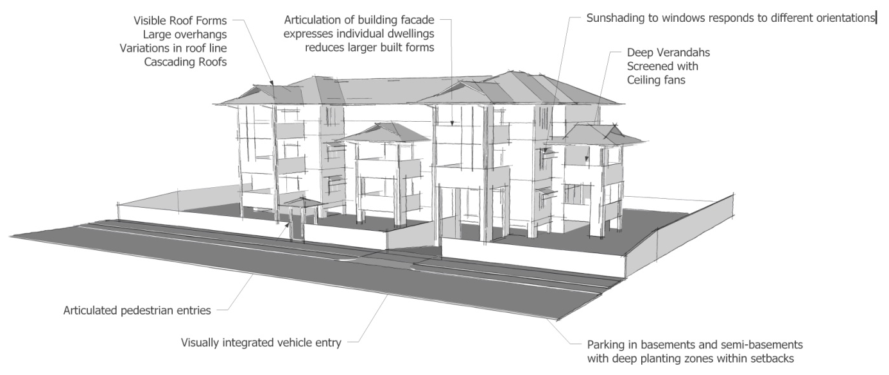
Figure 9.3.15.3.a – Tropical design elements
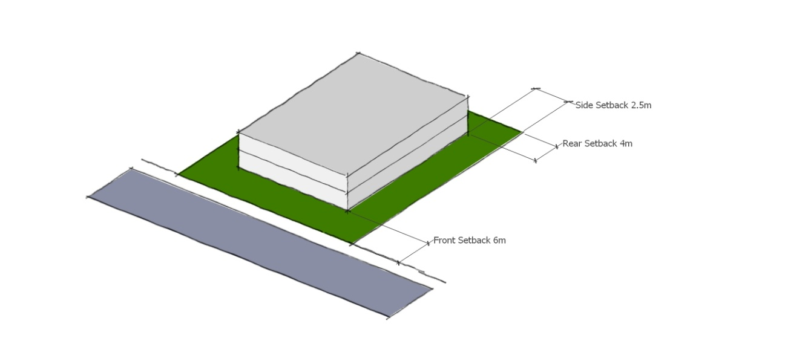
Figure 9.3.15.3.b – Setbacks – 1 or 2 storey Multiple dwellings
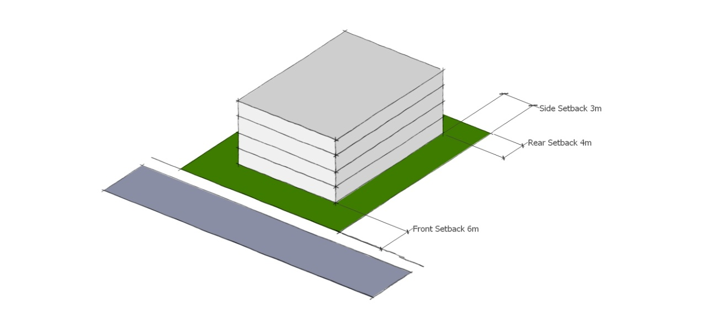

Figure 9.3.15.3.c – Setbacks – 3 or 4 storey Multiple dwellings

