Natural areas overlay code

Application
This code applies to assessing development within the Natural areas overlay as shown on the Natural areas overlay maps contained in Schedule 2. When using this code, reference should be made to Part 5.

Purpose
- The purpose of the Natural areas overlay is to protect the natural areas of the region through:
  - avoiding development within areas of environmental significance, wetlands and declared fish habitat areas;
  - minimising direct and indirect adverse impacts of development on areas of environmental significance;
  - minimising adverse impacts on sensitive receiving environments;
  - encouraging expansion of habitat and ecological connectivity and restoration of terrestrial and aquatic ecosystems.

- The purpose of the code will be achieved through the following overall outcomes:
  - development is located to avoid adverse impacts on areas of environmental significance;
  - where development cannot be located to avoid adverse impacts on areas of environmental significance, development:
    - protects and enhances areas of environmental significance;
    - provides appropriate buffers to areas of environmental significance;
    - protects known populations and supporting habitat of rare and threatened flora and fauna species, as listed in relevant State and Commonwealth legislation;
    - ensures that adverse direct or indirect impacts on areas of environmental significance are minimised through design, siting, operation, management and mitigation measures;
    - does not cause adverse impacts on the integrity and quality of water in upstream or downstream catchments, including declared fish habitat areas and the Great Barrier Reef World Heritage Area;
    - protects and maintains ecological and hydrological functions of waterways, wetlands, waterway corridors and declared fish habitat areas;
    - enhances connectivity across barriers for aquatic species and habitats;
    - rehabilitates degraded areas to provide improved habitat condition, connectivity, function and extent;
    - protects areas of environmental significance from weeds, pests and invasive species;
    - maintains or enhances ecological process and connectivity by avoiding fragmentation of areas of environmental significance;
  - development maintains and enhances ecological connectivity between habitats to support the health and resilience of biodiversity;
  - development avoids off-site impacts on adjacent areas of environmental significance;
  - strategic rehabilitation is directed to areas on or off site where it is possible to achieve expanded habitats and increased connectivity;
  - development avoids adverse impacts on the natural and cultural heritage significance of the Wet Tropics of Queensland World Heritage Area.

Note – The Wet Tropics of Queensland World Heritage Area is identified on the Strategic framework maps and Part 10 Other Plans contained in Schedule 2. Council may seek Third-party advice from the Wet Tropics Management Authority in relation to development applications within the Wet Tropics of Queensland World Heritage Area.

Assessment benchmarks and requirements
Table 8.2.11.3.a – Natural areas overlay code – assessment benchmarks for assessable development and requirements for accepted development
Performance outcomes | Acceptable outcomes | Applicant response
For accepted development subject to requirements and assessable development
Development within MLES – Urban waterway A trigger area
PO1  Development is set back from the Urban waterway A to protect and maintain:  - water quality;  - hydrological functions;  - ecological processes;  - biodiversity values;  - riparian and instream habitat values and connectivity;  - instream migration.  Note – An ecological assessment report may be required to demonstrate compliance with the performance outcome.  Planning scheme policy – Natural environment provides guidance on preparing an ecological assessment report. | AO1.1  Development is on a lot within a Residential zone and:  - the subject waterway is contained within an easement, covenant, adjoining reserve for waterway purposes or adjoining land under local government control that has a drainage function;  - the development does not occur within that easement, covenant or adjoining reserve or adjoining land under local government control;  or  AO1.2  Development is on a lot within a Residential zone and is located within a building envelope as identified on a Building Envelope Plan that applies to the land under a condition of a relevant approval;  or  AO1.3  Development is on a lot that is separated from the subject waterway by an existing, constructed road within a dedicated road reserve;  or

Performance outcomes | Acceptable outcomes | Applicant response
AO1.4
Development does not occur on the part of the lot affected by a waterway corridor.

Note – refer to the definition of Residential zone within Schedule 1.2.

Note – Waterway corridor widths are identified within Table 8.2.11.3.b. Figure 8.2.11.a shows the location of waterway corridors for a waterway.

Note – Figures 8.2.11.3.b, 8.2.11.3.c, 8.2.11.3.d and 8.2.11.3.e
provide guidance on meeting AO1.2, AO1.2, AO1.3 and AO1.4.
Development within the MLES – Urban waterway B trigger area
PO2  Development is set back from the Urban waterway B to protect and maintain:  - water quality;  - hydrological functions;  - ecological processes;  - biodiversity values;  - riparian and instream habitat values and connectivity;  - instream migration.  Note – An ecological assessment report may be required to demonstrate compliance with the performance outcome.  Planning scheme policy – Natural environment provides guidance on preparing an ecological assessment report. | AO2.1  Development is a lot where the subject waterway is contained within an easement, covenant, adjoining reserve for waterway purposes or adjoining land under local government control that has a drainage function, and development does not occur within the easement, covenant or adjoining reserve or adjoining land under local government control;  or  AO2.2  Development is on a lot that is separated from the subject waterway by an existing, constructed road within a dedicated road reserve;  or  AO2.3  Development does not occur on the part of the lot affected by a waterway corridor.

Performance outcomes | Acceptable outcomes | Applicant response
Note – Waterway corridors are identified within Table 8.2.11.3.b. Figure 8.2.11.3.a shows the location of waterway corridors for a waterway.

Note – Figures 8.2.11.3.b, 8.2.11.3.d and 8.2.11.3.e provide guidance on meeting AO2.1, AO2.2, and AO2.3.
Development within the MLES – Non-urban waterway trigger area
PO3  Development is set back from the Non-urban waterway to protect and maintain:  - water quality;  - hydrological functions;  - ecological processes;  - biodiversity values;  - riparian and instream habitat values and connectivity;  - instream migration.  Note – An ecological assessment report may be required to demonstrate compliance with the performance outcome.  Planning scheme policy – Natural environment provides guidance on preparing an ecological assessment report. | AO3.1  Development is on a lot within a Residential zone and:  - the subject waterway is contained within an easement, covenant, adjoining reserve for waterway purposes or adjoining land under local government control that has a drainage function;  - the development does not occur within that easement, covenant or adjoining reserve or adjoining land under local government control;  or  AO3.2  Development is on a lot within the Rural residential zone and is located within a building envelope as identified on a Building Envelope Plan that applies to the land under a condition of a relevant approval;  or  AO3.3  Development is on a lot that is separated from the subject waterway by an existing, constructed road within a dedicated road reserve;  or

Performance outcomes | Acceptable outcomes | Applicant response
AO3.4
Development does not occur on the part of the lot affected by a waterway corridor.

Note – refer to the definition of Residential zone within Schedule 1.2.

Note – Waterway corridor widths are identified within Table 8.2.11.3.b. Figure 8.2.11.3.a. shows the location of waterway corridors for a waterway.

Note – Figures 8.2.11.3.b, 8.2.11.3.c, 8.2.11.3.d and 8.2.11.3.e
provide guidance on meeting AO3.1, AO3.2, AO3.3 and AO3.4.
For assessable development
Areas of environmental significance
PO4  Development does not cause direct or indirect adverse impacts on areas of environmental significance.  Note – An ecological assessment report may be required to demonstrate compliance with the performance outcome.  Planning scheme policy – Natural environment provides guidance on preparing an ecological assessment report. | AO4.1  Development is:  - avoided within areas of environmental significance;  - set back from areas of environmental significance to the greatest possible extent and is designed to buffer and minimise edge effects and other indirect impacts on areas of environmental significance;  or  AO4.2  Where development within an area of environmental significance cannot be avoided, development ensures adverse impacts on areas of environmental significance are minimised by:  - designing, siting, operating and managing development to:  - minmise the development footprint;  - be situated within existing cleared areas, including necessary fire management infrastructure and fire breaks;

Performance outcomes | Acceptable outcomes | Applicant response
- ensure wildlife habitat is protected;
- ensure unrestricted fauna movement;
- retain and restore habitat corridors and biodiversity values;
- provide appropriate buffers to biodiversity areas;
- maximise ecological connectivity between areas of significance by retaining continuous vegetated corridors;
- minimise light and noise emission into biodiversity areas;
- manage domestic animal movements, through adequate containment.
- protecting and maintaining the values of biodiversity areas;
- providing for strategic rehabilitation of vegetation species and coverage, and habitat connectivity;
- protecting undeveloped areas of environmental significance through appropriate land tenure;
- rehabilitating degraded areas to improve habitat condition, function and extent.

Note – An ecological assessment report may be required to demonstrate compliance with the AO4.2.

Note - Planning scheme policy – Natural environment provides guidance on preparing an ecological assessment report.
Water quality and integrity
PO5  Development does not cause adverse impacts on the quality and integrity of water in upstream or down-stream catchments, including the Great Barrier Reef Marine Park. | AO5.1  No acceptable outcomes are provided.

Performance outcomes | Acceptable outcomes | Applicant response
Note – An ecological assessment report may be required to demonstrate compliance with the performance outcome.
Planning scheme policy – Natural environment provides guidance on preparing an ecological assessment report.
Additional requirements for Declared fish habitat areas
PO6  Development does not cause adverse impacts on fish habitat values.  Note – An ecological assessment report may be required to demonstrate compliance with the performance outcome.  Planning scheme policy – Natural environment provides guidance on preparing an ecological assessment report | AO6.1  Development ensures adverse impacts on fish habitat values are avoided by designing, siting, operating and managing development to:  - contribute to the protection of fish habitat values;  - maintain the quality and integrity of declared fish habitat areas and water entering them.
Additional requirements for Wetlands and wetland buffer areas
PO7  Development does not occur within a wetland. | AO7.1  No acceptable outcomes are provided.
PO8  Development is set back from wetlands to maintain water quality, ecological and hydrological functions and values of wetlands and their receiving waters.  Note – An ecological assessment report may be required to demonstrate compliance with the performance outcome.  Planning scheme policy – Natural environment provides guidance on preparing an ecological assessment report. | AO8.1  Development is set back from MSES – High ecological significance wetlands and MSES – High ecological value waters (wetland) in accordance with Table 8.2.11.3.c;  or  AO8.2  Where an alternative setback is proposed, the width of the alternative is supported by an evaluation of the environmental values, functioning and threats to the wetland.  Note -The MSES – Wetland buffer area identifies the urban and non-urban setback area from the MSES – High ecological significance and MSES – High ecological value waters (wetland).

Performance outcomes | Acceptable outcomes | Applicant response
AO8.3
Development does not occur within an area identified as MSES – Regulated vegetation (wetlands).

Note – The mapped area for MSES – Regulated vegetation (wetland) includes a buffer area.
PO9  Wetlands and wetland buffer areas are maintained, protected and restored.  Note – Wetland buffer areas are identified within Table 8.2.11.3.c. | AO9.1  Native vegetation within wetlands and wetland buffer areas is retained.
AO9.2
Degraded sections of wetlands and wetland buffer areas are revegetated with native plants in patterns and densities which emulate the relevant regional ecosystem.
Additional requirements for waterways and waterway trigger areas
PO10  Development is set back from waterways to protect and maintain:  - water quality;  - hydrological functions;  - ecological processes;  - biodiversity values;  - riparian and instream habitat values and connectivity;  - instream migration.  Note – An ecological assessment report may be required to demonstrate compliance with the performance outcome. Planning scheme policy – Natural environment provides guidance on preparing an ecological assessment report. | AO10.1  Waterway corridors are provided adjacent to waterways in accordance with the requirements of Table 8.2.11.3.b.  or  AO10.2  Where a waterway corridor of an alternative width is proposed, the alternative width is supported by an evaluation of the waterway to ensure the protection and maintenance of:  - water quality;  - hydrological functions;  - opportunities for instream migration;  - ecological processes;  - riparian and instream habitat values and connectivity;  - biodiversity values.

Performance outcomes | Acceptable outcomes | Applicant response
 | Note – An ecological assessment report may be required to demonstrate compliance with the performance outcome. Planning scheme policy – Natural environment provides guidance on preparing an ecological assessment report
AO10.3
Development, other than Community infrastructure or open space is not located within a waterway or waterway corridor.
Additional requirements for development within the MLES – Urban waterway A trigger area and MLES
- Non-urban waterway trigger area
PO11  Waterways and waterway corridors are protected, and degraded areas are restored and waterways and waterway corridors transferred to public ownership. | AO11.1  Native vegetation within waterways and waterway corridors is retained.
AO11.2
Waterway corridors are:
- transferred to public ownership for an appropriate reserve purpose; or
- protected through an Environmental Covenant.
AO11.3
Degraded sections of waterways and waterway corridors are revegetated with endemic plant species in patterns and densities which emulate the natural state of waterway corridors within the area.
AO11.4
The lowest intensity of development is located adjacent to the waterway corridor.

Table 8.2.11.3.b – Widths of waterway corridors for waterways
Waterway classification | Waterway corridor width
Urban waterway A | 10 metres on each side of the waterway, measured perpendicular from the top of the high bank.
Urban waterway B | 5 metres on each side of the waterway, measured perpendicular from the top of the high bank.
Non-urban waterway | 25 metres on each side of the waterway, measured perpendicular from the top of the high bank.

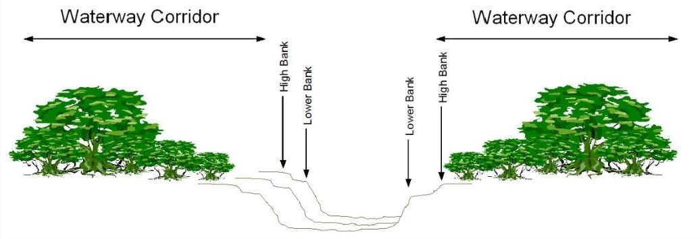
Note – Waterway classifications are identified through corresponding waterway trigger areas on the Natural areas overlay maps contained in Schedule 2 and defined in Schedule 1.2. Note – Figure 8.2.11.3.a. shows the location of waterway corridors for a waterway.

Figure 8.2.11.3.a - Waterway Corridors

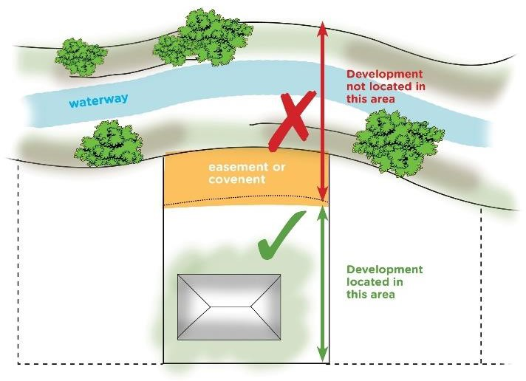

Figure 8.2.11.3.b – Requirements for development in accordance with AO1.1, AO2.1 and AO3.1

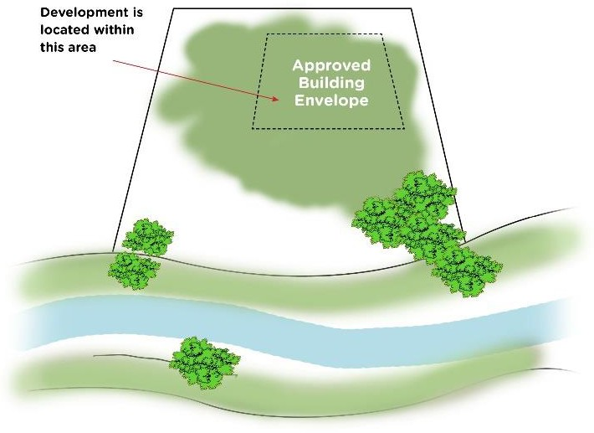

Figure 8.2.11.3.c – Requirements for development in accordance with AO1.2 and AO3.2

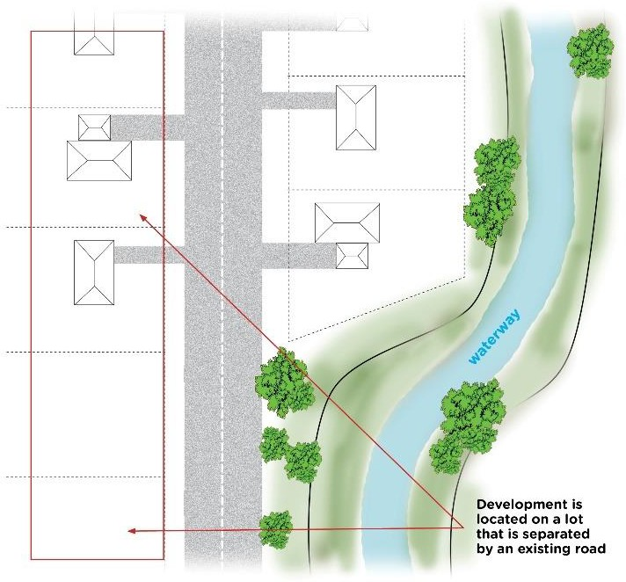

Figure 8.2.11.3.d – Requirements for development in accordance with AO1.3, AO2.2 and AO3.3
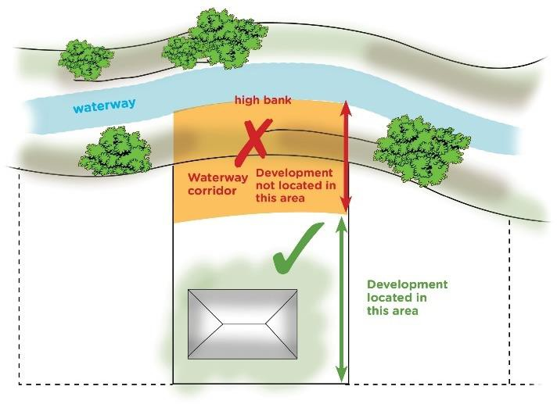

Figure 8.2.11.3.e – Requirements for development in accordance with AO1.4, AO2.3 and AO3.4

Table 8.2.11.3.c — Setbacks for wetlands
Wetland classification | Setback
Urban wetland | 50 metres from the edge of the wetland.
Non-urban wetland | 200 metres from the edge of the wetland.

Note – For the purpose of Table 8.2.11.3.c a Non-urban wetland is a wetland that is located within the Conservation zone, Environmental management zone, Rural zone or Rural residential zone. An Urban wetland is a wetland located within any other zone.

