Neighbourhood character overlay code

Application
This code applies to assessing development within the Neighbourhood character overlay as shown on the Neighbourhood character overlay maps contained in Schedule 2.

When using this code, reference should be made to Part 5.

Purpose
- The purpose of the Neighbourhood character overlay code is to ensure that:
  - Neighbourhood character places, Neighbourhood character streetscapes and Neighbourhood character areas are retained and protected;
  - development is consistent with, and complementary and responsive to the distinctive character of the Neighbourhood character place, Neighbourhood character streetscape and Neighbourhood character area.

- The purpose of the code will be achieved through the following overall outcomes:
  - Development is consistent with, and complementary and responsive to the Neighbourhood character elements displayed on the Neighbourhood character place, within the Neighbourhood character streetscape and the Neighbourhood character area, including but not limited to:
    - architectural style of buildings and structures (including roof style);
    - building materials;
    - pattern of development;
    - setbacks;
    - building height, form, scale and bulk;
    - layout and orientation of buildings and structures;
    - access, car parking and vehicle storage;
    - lot layout, sizes, dimensions and frontages;
    - site cover;
    - topography;
    - fencing, landscaping and vegetation;
    - street trees;
  - Extensions, alterations or additions to a Neighbourhood character place do not dominate or detract from the existing Neighbourhood character elements of the Neighbourhood character place or Neighbourhood character streetscape;
  - Extensions, alterations and additions incorporate the Neighbourhood character elements of the existing Neighbourhood character place;
  - Development for reconfiguring a lot results in a lot layout, lot sizes, lot dimensions and frontages, and access that are consistent with the existing Neighbourhood character elements within the Neighbourhood character streetscape and Neighbourhood character area;
  - Buildings and structures on a Neighbourhood character place are retained and are not demolished or removed from the site, unless the building or structure:

    - is not structurally sound and cannot reasonably be made structurally sound; or
    - does not reflect the character of the Neighbourhood character place, the neighbourhood character streetscape and the neighbourhood character area.

Note – Planning scheme policy- Neighbourhood character provides guidance on meeting the outcomes sought in this code. Council may request that a development application in a Neighbourhood character area is accompanied by a Neighbourhood character assessment. Planning Scheme Policy – Neighbourhood character provides guidance on how to prepare a Neighbourhood character assessment.

Note – Refer to the definitions of Neighbourhood character place, Neighbourhood character streetscape, Neighbourhood character area and Neighbourhood character elements contained within Schedule 1.2.

Note – Where 8.2.12.2(2)(e)(i) applies, the development application must be accompanied by a report prepared by a Registered Professional Engineer of Queensland (RPEQ) demonstrating that the building or structure is not structurally sound and cannot reasonably be made structurally sound.

Note – Where 8.2.12.2(2)(e)(ii) applies, Council may require a report prepared by a suitably qualified and experienced heritage consultant demonstrating that the building or structure does not reflect the character of the Neighbourhood character place, Neighbourhood character streetscape and Neighbourhood character area. A Neighbourhood character assessment prepared in accordance with the Planning scheme policy – neighbourhood character is required to identify the Neighbourhood character elements.

Assessment benchmarks and requirements
Table 8.2.12.3.a – Neighbourhood character overlay code – assessment benchmarks for assessable development and requirements for accepted development
Performance outcomes | Acceptable outcomes | Applicant response
For accepted development subject to requirements and assessable development
Design and siting
PO1  When viewed from a Neighbourhood character streetscape, garages, carports, patios, verandahs, balconies, sheds, extensions, and other ancillary buildings and structures:  - are subservient to the Neighbourhood character place;  - are consistent with the Neighbourhood character streetscape;  - do not conceal a building on a Neighbourhood character place;  - do not detract from the appearance of existing buildings and Neighbourhood character elements on a Neighbourhood character place | AO1.1  Development is for Building work or Minor building work and is located in area A on Figure 8.2.12.3.a;  or  AO1.2  Development is for a garage or carport and is located wholly under or within an existing building and any associated building works comply with AO3.1;  or

Performance outcomes | Acceptable outcomes | Applicant response
or the overall character of the Neighbourhood character streetscape;  - incorporate the Neighbourhood character elements displayed by the Neighbourhood character place;  - maintains the detached dwelling pattern of development within the Neighbourhood character area. | AO1.3  Development is for a carport located in area B shown in Figure 8.2.12.3.a where:  - it is a single vehicle carport no greater than 3m in width and in height;  - it has no enclosure to any side.  Note – Height is inclusive of the roof height.
PO2  Driveways and crossovers are limited in number and complement, and do not detract from, the overall appearance and character of the Neighbourhood character area, Neighbourhood character streetscape and neighbourhood character area. | AO2.1  Development results in no more than one access crossover with a maximum driveway width of 3 metres.
Raising buildings and enclosing understoreys
PO3  Development involving the enclosure of the under storey area of a building:  - preserves the dominant visual form of the upper storey;  - does not detract from the overall character of the Neighbourhood character place or the neighbourhood character streetscape.  Note – Planning scheme policy - Neighbourhood character provides guidance on meeting the Performance outcome. | AO3.1  Development involving the enclosure of the under story area of a building:  - is recessed behind a street front façade of the upper storey by a minimum of 1 metre;  - does not increase the site cover on the site.
PO4  Development involving the raising of buildings on a site:  (a) balances the proportions of the upper and lower storeys; | AO4.1  Development involving the raising of buildings on a site does not reduce the existing front or side boundary setback.
AO4.2
Raising of buildings does not:

Performance outcomes | Acceptable outcomes | Applicant response
- maintains the streetscape pattern of development, including front and side setbacks;  - does not detract from the character or amenity of the Neighbourhood character streetscape;  - results in an overall height that is consistent with the height of Neighbourhood character places within the Neighbourhood character streetscape. | - increase the height of the lower storey floor level by more than 0.5 metres from ground level;  - result in the floor level of the upper storey being more than 3.5 metres from the existing ground level.
For assessable development
Design
PO5  Development on a Neighbourhood character place:  - does not remove, diminish, dominate or conceal the existing neighbourhood character elements of the place;  - reflects the Neighbourhood character elements of the Neighbourhood character streetscape and Neighbourhood character area including, but not limited to:  - architectural style of buildings and structures (including roof style);  - building materials;  - pattern of development;  - setbacks;  - building height, form, scale and bulk;  - layout and orientation of buildings and structures;  - access, car parking and vehicle storage;  - lot layout, lot sizes, dimensions and frontages;  - site cover;  - topography; | AO5.1  No acceptable outcomes are provided.

Performance outcomes | Acceptable outcomes | Applicant response
- fencing, landscaping and vegetation;
- street trees;
- incorporates materials, finishes and colours that are consistent with the existing buildings and structures on the Neighbourhood character place;
- is sympathetic to and not obtrusive in the neighbourhood character streetscape;

Note – A Neighbourhood character assessment may be required to demonstrate compliance with this performance outcome.
Planning scheme policy - Neighbourhood character provides guidance on preparing a Neighbourhood character assessment.
PO6  Development is designed and sited to retain existing significant trees on the site. | AO6.1  No acceptable outcomes are provided.
PO7  Fences do not detract from or conceal the overall appearance and character of the Neighbourhood character place, Neighbourhood character streetscape and neighbourhood character area. | AO7.1  Fences to a road frontage are not more than: (a)1.2 metres in height if solid; or  (b)1.5 metres in height if a minimum of 50% transparent.
PO8  Buildings relocated onto a Neighbourhood character place are of a scale and character that is compatible with the Neighbourhood character streetscape and Neighbourhood character area. | AO8.1  No acceptable outcomes are provided.
Additional requirements for Secondary dwellings
PO9  The secondary dwelling is located and designed in a manner that:  (a) does not detract from or conceal any existing Neighbourhood character elements of the Neighbourhood character place; | AO9.1  No acceptable outcomes are provided.

Performance outcomes | Acceptable outcomes | Applicant response
- does not dominate the streetscape and is subservient to the primary dwelling on the Neighbourhood character place;
- maintains the detached dwelling pattern of development within the Neighbourhood character area;
- uses materials, finishes and colours that complement the existing buildings and structures on the neighbourhood character place;
- incorporates the Neighbourhood character elements displayed by the primary dwelling;
- reflects the Neighbourhood character elements of the Neighbourhood character streetscape and Neighbourhood character area.
Demolition, removal or repositioning
PO10  Development involving demolition only occurs where:  - the building or structure is not structurally sound and cannot reasonably be made structurally sound; or  - the building or structure does not reflect the character of the Neighbourhood character place, Neighbourhood character streetscape and Neighbourhood character area.  Note – Where PO10(a) applies, the development application must be accompanied by a report prepared by a Registered Professional Engineer of Queensland (RPEQ) demonstrating that the building or structure is not structurally sound and cannot reasonably be made structurally sound. | AO10.1  No acceptable outcomes are provided.

Performance outcomes | Acceptable outcomes | Applicant response
Note – Where PO10(b) applies, Council may require a report prepared by a suitably qualified and experienced heritage consultant demonstrating that the building or structure does not reflect the character of the Neighbourhood character place, Neighbourhood character streetscape and Neighbourhood character area. A Neighbourhood character assessment prepared in accordance with the Planning scheme policy – neighbourhood character is required to identify the Neighbourhood character elements.
PO11  Buildings and structures on a Neighbourhood character place are not removed from their original lot and are not relocated to another lot, except where undertaken in accordance with PO10.  Note – The relocation of a building or structure within the same Neighbourhood character area does not satisfy this performance outcome.  Note – the removal of a Neighbourhood character place is demolition and must also comply with PO10. | AO11.1  No acceptable outcomes are provided.
PO12  Where buildings and structures on a Neighbourhood character place are repositioned on the same lot, the new position of the building or structure:  - is consistent with the position of other comparable buildings and structures on Neighbourhood character places within the same Neighbourhood character streetscape;  - does not conceal Neighbourhood character elements displayed by the subject Neighbourhood character place or adjoining Neighbourhood character places, when viewed from the street;  - complies with relevant setbacks or boundary clearance provisions. | AO12.1  No acceptable outcomes are provided.

Performance outcomes | Acceptable outcomes | Applicant response
PO13  Where buildings and structures on a Neighbourhood character place are repositioned on the same lot to accommodate additional or future development, the repositioned building or structure must be sited to:  - comply with the relevant assessment benchmarks within the planning scheme that are applicable to the existing development; and  - allow sufficient area to accommodate the additional or future development in a manner that complies with the relevant assessment benchmarks for that development.  Note – Where the repositioning is proposed to allow for additional or future development on the site, the development application will need to include plans for the additional or future development and demonstrate how the additional or future development can be accommodated on the site in a manner that complies with relevant assessment benchmarks within the planning scheme. | AO13.1  No acceptable outcomes are provided.
Additional requirements for Reconfiguring a lot
PO14  Development for Reconfiguring a lot results in lot configuration, lot sizes, lot dimensions and frontages, and access that are consistent with the existing Neighbourhood character elements within the neighbourhood character streetscape and Neighbourhood character area.  Note – A Neighbourhood character assessment may be required to demonstrate compliance with this performance outcome.  Planning scheme policy - Neighbourhood character provides guidance on preparing a Neighbourhood character assessment. | AO14.1  No acceptable outcomes are provided.

Performance outcomes | Acceptable outcomes | Applicant response
Additional requirements for development within Neighbourhood character area 6 – Freshwater and Neighbourhood character area 11 - Stratford
PO15  Development for Reconfiguring a lot within Neighbourhood character area 6 – Freshwater or Neighbourhood character area 11 – Stratford does not result in:  - lots with an area of less than 600m2 (excluding the area of access strips) within the Low density residential zone;  - lots with an area of less than 450m2 (excluding the area of access strips) within the Low-medium density residential zone;  - more than one rear lot. | AO15.1  No acceptable outcomes are provided.
PO16  Development for Dual occupancy within Neighbourhood character area 6 – Freshwater or Neighbourhood character area 11 – Stratford does not occur on a lot with an area less than:  - 800m2 within the Low density residential zone; or  - 600m2 within the Low-medium density residential zone. | AO16.1  No acceptable outcomes are provided.

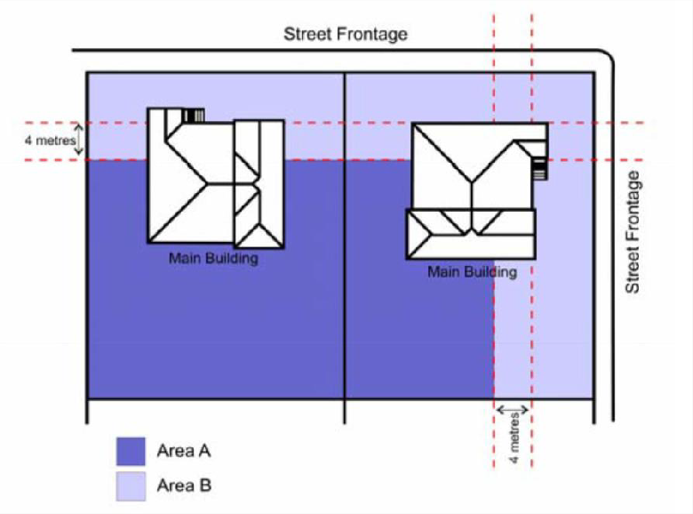

Figure 8.2.12.3.a – Consistent design solutions for AO1.1 and AO1.3.

